

East West University

Course Code & Name: CSE 302 (Database Systems)
Course Instructor: Sanzana Karim Lora
Course Section: 10
Academic Session: Summer 2025
Project Report

Group No.- 03
Group Members:
Name | Id | Contribution
Md. Abir Rahman | 2023-3-60-223 | 25%
Md Julfiker Hossain | 2023-3-60-490 | 25%
Sudeepta Mandal | 2023-3-60-222 | 25%
Md. Rashid Uz Zaman | 2023-3-60-195 | 25%

Project Title:
**BPL DataVault : A BPL Database Management System**
Submission Date & Day: September 04, 2025 (Thursday)
Table of Contents
Topic | Page No.
ER- Model: Relational Diagram | 03
Implementation Checklist | 04
Normalization | 05-14
Pages | 15-42
Authorization and User Role Assignment | 42
Page-Wise Authorization Information | 43
Conclusion | 45

ER- Model: Relational Diagram:
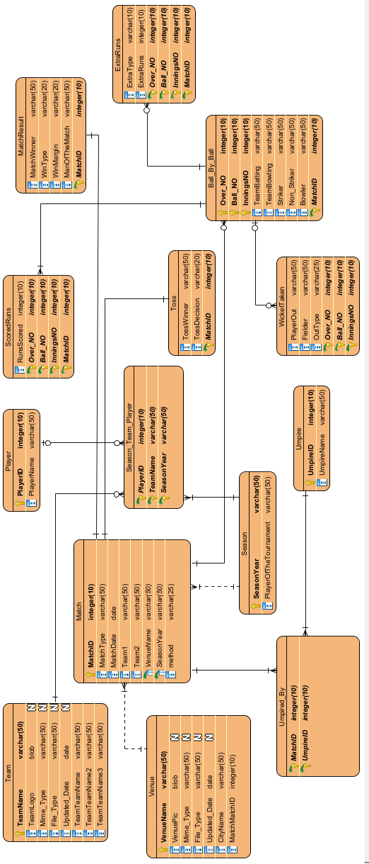

Implementation Checklist:
Description | Remarks
Project ID | 14889
Workspace Name | Sakin_Workspace
Workspace Email | abirrahman.sakin@gmail.com
Workspace Password | #spsakin@329
Authentication Type | Custom
Username and Password to Login | User: sakin (Administrator)  Password: lion  User: julfiker (Administrator)  Password: monkey  User: sudeep (Administrator)  Password: sheep  User: rashed (Administrator)  Password: rashed
User: thor (Contributor)
Password: loki
User: messi (reader)
Password: goat

User: neymar (reader)
Password: goat

User: ronaldo (reader)
Password: goat
Uploaded and Displayed Images in Reports | yes
Implemented Page-wise Authorization | yes
Number of Total Pages | 51
Number of Reports with Forms | 34
Number of Reports based on Queries, Aggregate Queries | 13
Number of Graphs/Charts | 9

Normalization:

1. Team
Column Name | Data Type | Constraints
TeamName | VARCHAR2 | NOT NULL, PRIMARY KEY
TeamLogo | BLOB
Team table is in BCNF.
Primary Key: TeamName
Non-Key columns: TeamLogo, Mime_Type, File_Type, Updated_Date.
Functional Dependencies:
TeamName → TeamLogo, Mime_Type, File_Type, Updated_Date
BCNF Check:
- 1NF (First Normal Form): All columns contain atomic values, no repeating groups.
- No Partial Dependencies: No partial dependencies exist; table satisfies 2NF.
- No Transitive Dependencies: No non-key attribute depends on another non-key attribute; satisfies 3NF.
- BCNF Rule: All functional dependencies have candidate keys on LHS.

2. Venue
Column Name | Data Type | Constraints
VenueName | VARCHAR2 | NOT NULL, PRIMARY KEY
VenuePic | BLOB
CityName | VARCHAR2
Venue table is in BCNF.
Primary Key: VenueName
Non-Key columns: VenuePic, Mime_Type, File_Type, Updated_Date, CityName.
Functional Dependencies:
VenueName → VenuePic, Mime_Type, File_Type, Updated_Date, CityName

BCNF Check:
- 1NF (First Normal Form): All columns contain atomic values, no repeating groups.
- No Partial Dependencies: No partial dependencies exist; table satisfies 2NF.
- No Transitive Dependencies: No non-key attribute depends on another non-key attribute; satisfies 3NF.
- BCNF Rule: All functional dependencies have candidate keys on LHS.

3. Match
Column Name | Data Type | Constraints
MatchID | NUMBER | NOT NULL, PRIMARY KEY
MatchType | VARCHAR2
MatchDate | DATE
Team1 | VARCHAR2
Team2 | VARCHAR2
VenueName | VARCHAR2
SeasonYear | VARCHAR2
Method | VARCHAR2
Match table is in BCNF.
Primary Key: MatchID
Non-Key columns: MatchType, MatchDate, Team1, Team2, VenueName, SeasonYear, Method.
Functional Dependencies:
MatchID → MatchType, MatchDate, Team1, Team2, VenueName, SeasonYear, Method
BCNF Check:
- 1NF (First Normal Form): All columns contain atomic values, no repeating groups.
- No Partial Dependencies: No partial dependencies exist; table satisfies 2NF.
- No Transitive Dependencies: No non-key attribute depends on another non-key attribute; satisfies 3NF.
- BCNF Rule: All functional dependencies have candidate keys on LHS.

4. Player
Column Name | Data Type | Constraints
PlayerID | NUMBER | NOT NULL, PRIMARY KEY
PlayerName | VARCHAR2
Player table is in BCNF.
Primary Key: PlayerID
Non-Key columns: PlayerName.
Functional Dependencies:
PlayerID → PlayerName
BCNF Check:
- 1NF (First Normal Form): All columns contain atomic values, no repeating groups.
- No Partial Dependencies: No partial dependencies exist; table satisfies 2NF.
- No Transitive Dependencies: No non-key attribute depends on another non-key attribute; satisfies 3NF.
- BCNF Rule: All functional dependencies have candidate keys on LHS.

5. Season
Column Name | Data Type | Constraints
SeasonYear | VARCHAR2 | NOT NULL, PRIMARY KEY
PlayerOfTheTournament | VARCHAR2
Season table is in BCNF.
Primary Key: SeasonYear
Non-Key columns: PlayerOfTheTournament.
Functional Dependencies:
SeasonYear → PlayerOfTheTournament
BCNF Check:
- 1NF (First Normal Form): All columns contain atomic values, no repeating groups.
- No Partial Dependencies: No partial dependencies exist; table satisfies 2NF.
- No Transitive Dependencies: No non-key attribute depends on another non-key attribute; satisfies 3NF.
- BCNF Rule: All functional dependencies have candidate keys on LHS.

6. Season_Team_Player
Column Name | Data Type | Constraints
PlayerID | NUMBER | PRIMARY KEY
TeamName | VARCHAR2 | PRIMARY KEY
SeasonYear | VARCHAR2 | PRIMARY KEY
Season_Team_Player table is in BCNF.
Primary Key: (PlayerID, TeamName, SeasonYear)
Non-Key columns: None.
Functional Dependencies:
No non-key attributes
BCNF Check:
- 1NF (First Normal Form): All columns contain atomic values, no repeating groups.
- No Partial Dependencies: No partial dependencies exist; table satisfies 2NF.
- No Transitive Dependencies: No non-key attribute depends on another non-key attribute; satisfies 3NF.
- BCNF Rule: All functional dependencies have candidate keys on LHS.

7. Umpire
Column Name | Data Type | Constraints
UmpireID | NUMBER | NOT NULL, PRIMARY KEY
UmpireName | VARCHAR2
Umpire table is in BCNF.
Primary Key: UmpireID
Non-Key columns: UmpireName.
Functional Dependencies:
UmpireID → UmpireName
BCNF Check:
- 1NF (First Normal Form): All columns contain atomic values, no repeating groups.
- No Partial Dependencies: No partial dependencies exist; table satisfies 2NF.
- No Transitive Dependencies: No non-key attribute depends on another non-key attribute; satisfies 3NF.
- BCNF Rule: All functional dependencies have candidate keys on LHS.

8. Umpired_By
Column Name | Data Type | Constraints
MatchID | NUMBER | PRIMARY KEY
UmpireID | NUMBER | PRIMARY KEY
Umpired_By table is in BCNF.
Primary Key: (MatchID, UmpireID)
Non-Key columns: None.
Functional Dependencies:
No non-key attributes
BCNF Check:
- 1NF (First Normal Form): All columns contain atomic values, no repeating groups.
- No Partial Dependencies: No partial dependencies exist; table satisfies 2NF.
- No Transitive Dependencies: No non-key attribute depends on another non-key attribute; satisfies 3NF.
- BCNF Rule: All functional dependencies have candidate keys on LHS.

9. Toss
Column Name | Data Type | Constraints
MatchID | NUMBER | NOT NULL, PRIMARY KEY
TossWinner | VARCHAR2
TossDecision | VARCHAR2
Toss table is in BCNF.
Primary Key: MatchID
Non-Key columns: TossWinner, TossDecision.
Functional Dependencies:
MatchID → TossWinner, TossDecision
BCNF Check:
- 1NF (First Normal Form): All columns contain atomic values, no repeating groups.
- No Partial Dependencies: No partial dependencies exist; table satisfies 2NF.
- No Transitive Dependencies: No non-key attribute depends on another non-key attribute; satisfies 3NF.
- BCNF Rule: All functional dependencies have candidate keys on LHS.

10. ScoredRuns
Column Name | Data Type | Constraints
OverNO | NUMBER | PRIMARY KEY
Ball_NO | NUMBER | PRIMARY KEY
InningsNo | NUMBER | PRIMARY KEY
MatchID | NUMBER | PRIMARY KEY
RunScored | NUMBER
ScoredRuns table is in BCNF.
Primary Key: (OverNO, Ball_NO, InningsNo, MatchID)
Non-Key columns: RunScored.
Functional Dependencies:
(OverNO, Ball_NO, InningsNo, MatchID) → RunScored
BCNF Check:
- 1NF (First Normal Form): All columns contain atomic values, no repeating groups.
- No Partial Dependencies: No partial dependencies exist; table satisfies 2NF.
- No Transitive Dependencies: No non-key attribute depends on another non-key attribute; satisfies 3NF.
- BCNF Rule: All functional dependencies have candidate keys on LHS.

11. MatchResult
Column Name | Data Type | Constraints
MatchID | NUMBER | NOT NULL, PRIMARY KEY
MatchWinner | VARCHAR2
WinType | VARCHAR2
WinMargin | VARCHAR2
ManOfTheMatch | VARCHAR2
MatchResult table is in BCNF.
Primary Key: MatchID
Non-Key columns: MatchWinner, WinType, WinMargin, ManOfTheMatch.
Functional Dependencies:
MatchID → MatchWinner, WinType, WinMargin, ManOfTheMatch
BCNF Check:
- 1NF (First Normal Form): All columns contain atomic values, no repeating groups.
- No Partial Dependencies: No partial dependencies exist; table satisfies 2NF.
- No Transitive Dependencies: No non-key attribute depends on another non-key attribute; satisfies 3NF.
- BCNF Rule: All functional dependencies have candidate keys on LHS.

12. ExtraRuns
Column Name | Data Type | Constraints
OverNO | NUMBER | PRIMARY KEY
Ball_NO | NUMBER | PRIMARY KEY
InningsNo | NUMBER | PRIMARY KEY
MatchID | NUMBER | PRIMARY KEY
ExtraType | VARCHAR2
ExtraRuns | NUMBER
ExtraRuns table is in BCNF.
Primary Key: (OverNO, Ball_NO, InningsNo, MatchID)
Non-Key columns: ExtraType, ExtraRuns.
Functional Dependencies:
(OverNO, Ball_NO, InningsNo, MatchID) → ExtraType, ExtraRuns
BCNF Check:
- 1NF (First Normal Form): All columns contain atomic values, no repeating groups.
- No Partial Dependencies: No partial dependencies exist; table satisfies 2NF.
- No Transitive Dependencies: No non-key attribute depends on another non-key attribute; satisfies 3NF.
- BCNF Rule: All functional dependencies have candidate keys on LHS.

13. Ball_By_Ball
Column Name | Data Type | Constraints
OverNO | NUMBER | PRIMARY KEY
Ball_NO | NUMBER | PRIMARY KEY
InningsNo | NUMBER | PRIMARY KEY
MatchID | NUMBER | PRIMARY KEY
TeamBatting | VARCHAR2
Team_Bowling | VARCHAR2
Striker | NUMBER
Non-Striker | NUMBER
Bowler | NUMBER
Ball_By_Ball table is in BCNF.
Primary Key: (OverNO, Ball_NO, InningsNo, MatchID)
Non-Key columns: TeamBatting, Team_Bowling, Striker, Non-Striker, Bowler.
Functional Dependencies:
(OverNO, Ball_NO, InningsNo, MatchID) → TeamBatting, Team_Bowling, Striker, Non-Striker, Bowler
BCNF Check:
- 1NF (First Normal Form): All columns contain atomic values, no repeating groups.
- No Partial Dependencies: No partial dependencies exist; table satisfies 2NF.
- No Transitive Dependencies: No non-key attribute depends on another non-key attribute; satisfies 3NF.
- BCNF Rule: All functional dependencies have candidate keys on LHS.

14. WicketTaken
Column Name | Data Type | Constraints
OverNO | NUMBER | PRIMARY KEY
Ball_NO | NUMBER | PRIMARY KEY
InningsNo | NUMBER | PRIMARY KEY
MatchID | NUMBER | PRIMARY KEY
PlayerOut | VARCHAR2
Fielder | VARCHAR2
OutType | VARCHAR2
WicketTaken table is in BCNF.
Primary Key: (OverNO, Ball_NO, InningsNo, MatchID)
Non-Key columns: PlayerOut, Fielder, OutType.
Functional Dependencies:
(OverNO, Ball_NO, InningsNo, MatchID) → PlayerOut, Fielder, OutType
BCNF Check:
- • 1NF (First Normal Form): All columns contain atomic values, no repeating groups.
- • No Partial Dependencies: No partial dependencies exist; table satisfies 2NF.
- • No Transitive Dependencies: No non-key attribute depends on another non-key attribute; satisfies 3NF.
- • BCNF Rule: All functional dependencies have candidate keys on LHS.

Pages:

Report Page Number and Name | Form Page Number and Name | Table
2. Ball_By_Ball | 3. Ball_By_Ball Form | Ball_By_Ball
4. ExtraRuns | 5. ExtraRuns Form | ExtraRuns
6. Match | 7. Match Form | Match
8. MatchResult | 9. MatchResult Form | MatchResult
10. Player | 11. Player Form | Player
12. ScoredRuns | 13. ScoredRuns Form | ScoredRuns
14. Season | 15. Season Form | Season
16. Season_Team_Player | 17. Season_Team_Player Form | Season_Team_Player
18. Team | 19. Team Form | Team
20. Toss | 21. Toss Form | Toss
22. Umpire | 23. Umpire Form | Umpire
24. UmpiredBy | 25. UmpiredBy Form | UmpiredBy
26. Venue | 27. Venue Form | Venue
28. WicketTaken | 29. WicketTaken Form | WicketTaken

Login page:
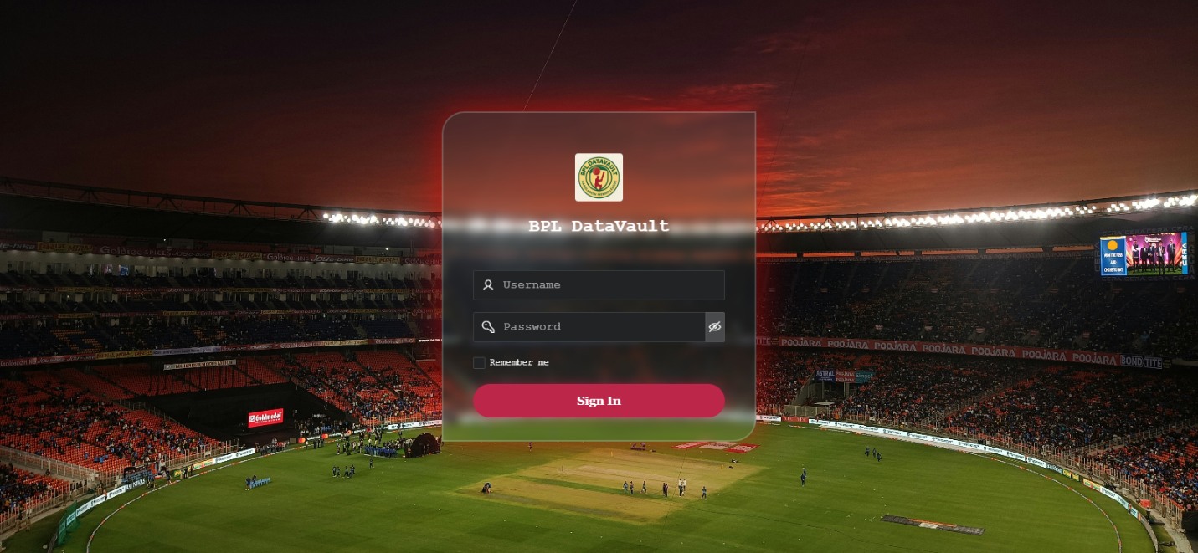

Dashboard: Home Page - 1
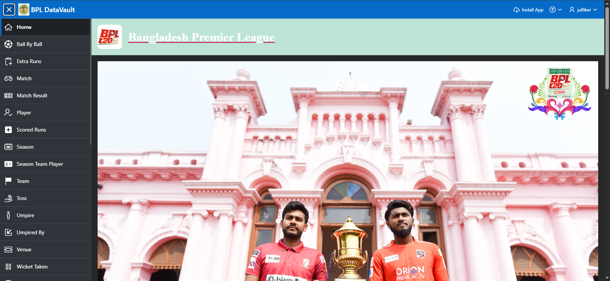

Page2: Ball_By_Ball Report Page
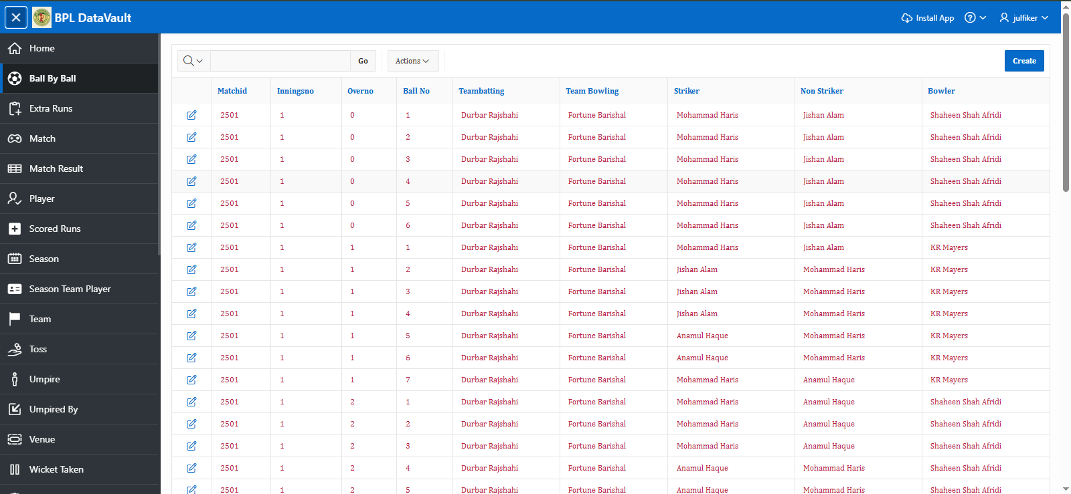

Page3: Ball_By_By Form Page
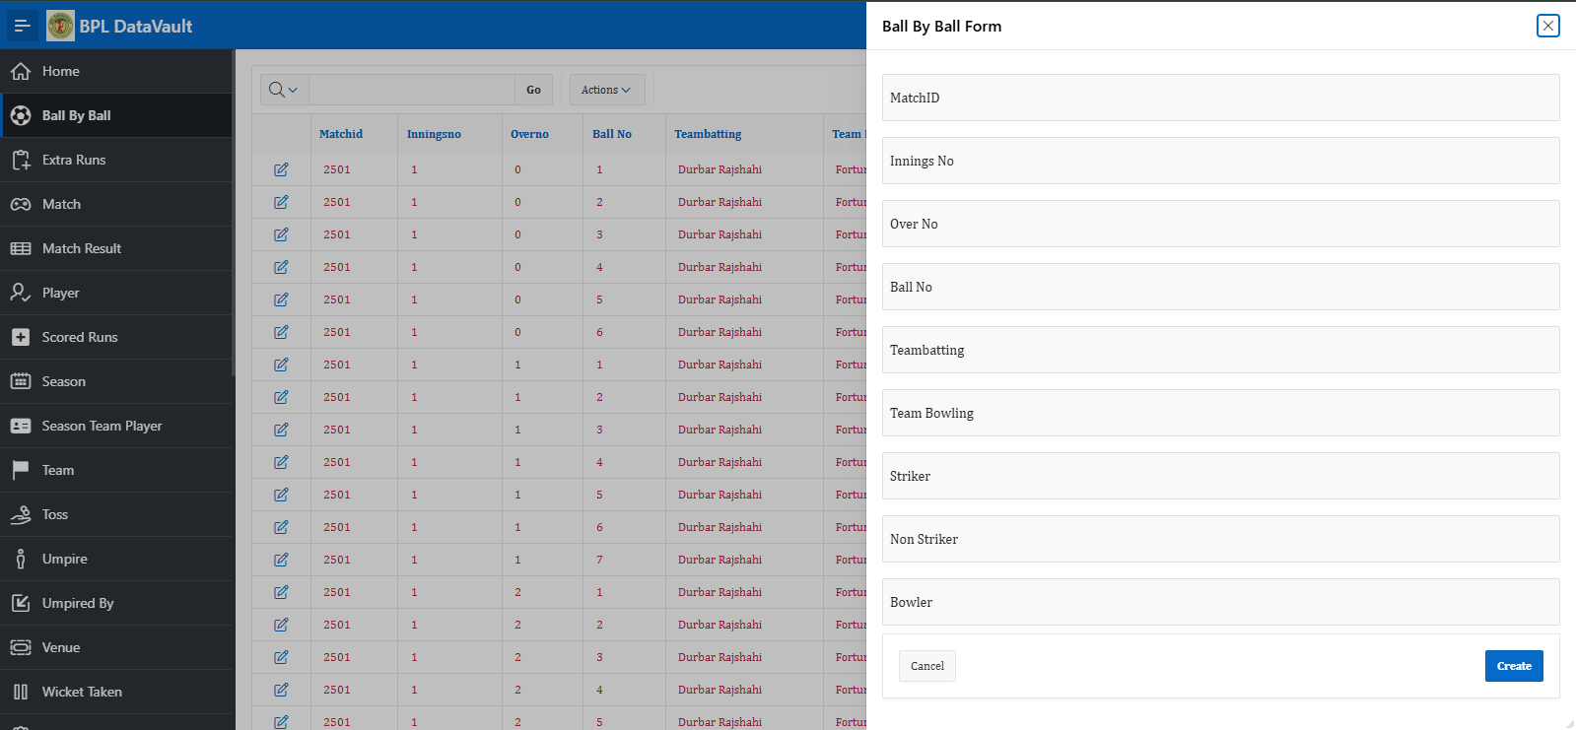

Page4: Extra Runs Report Page
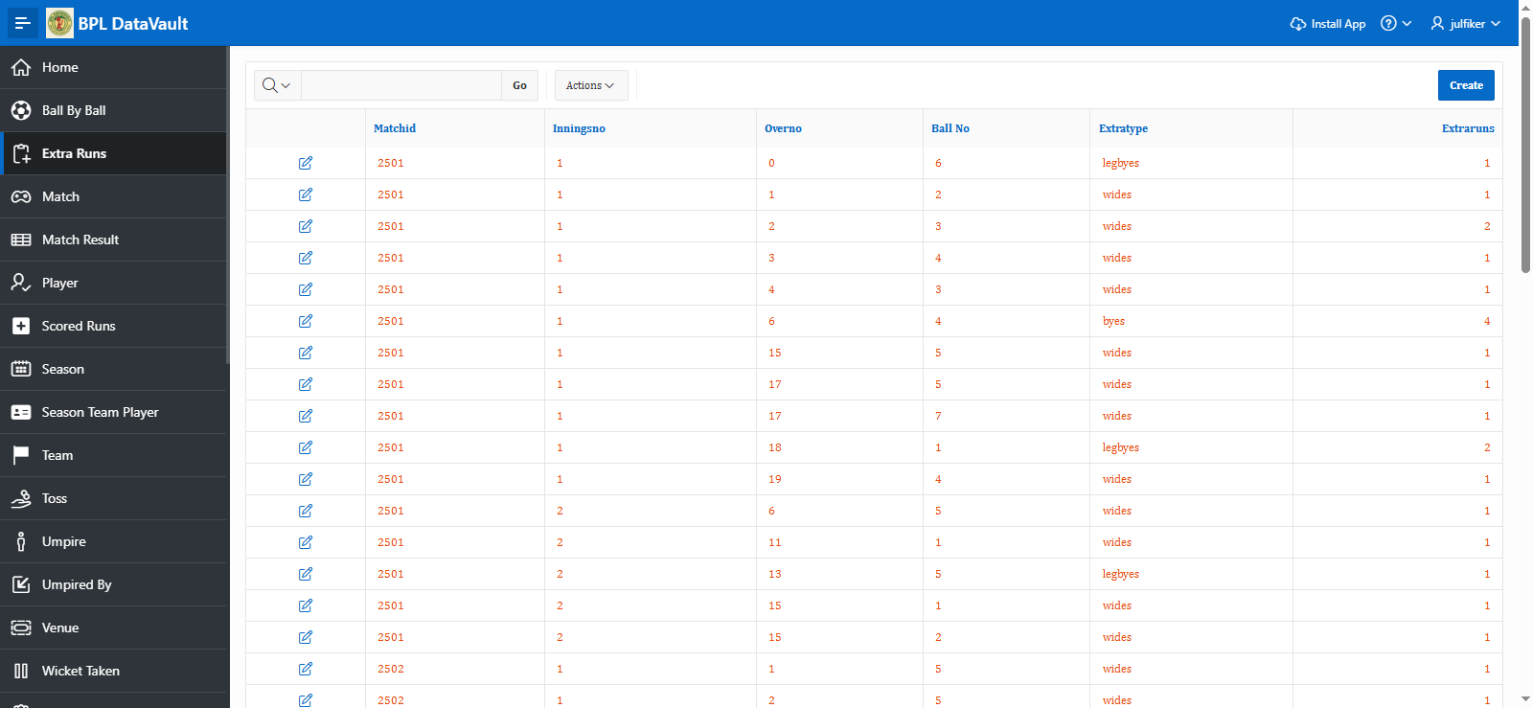

Page5: Extra Runs Form Page
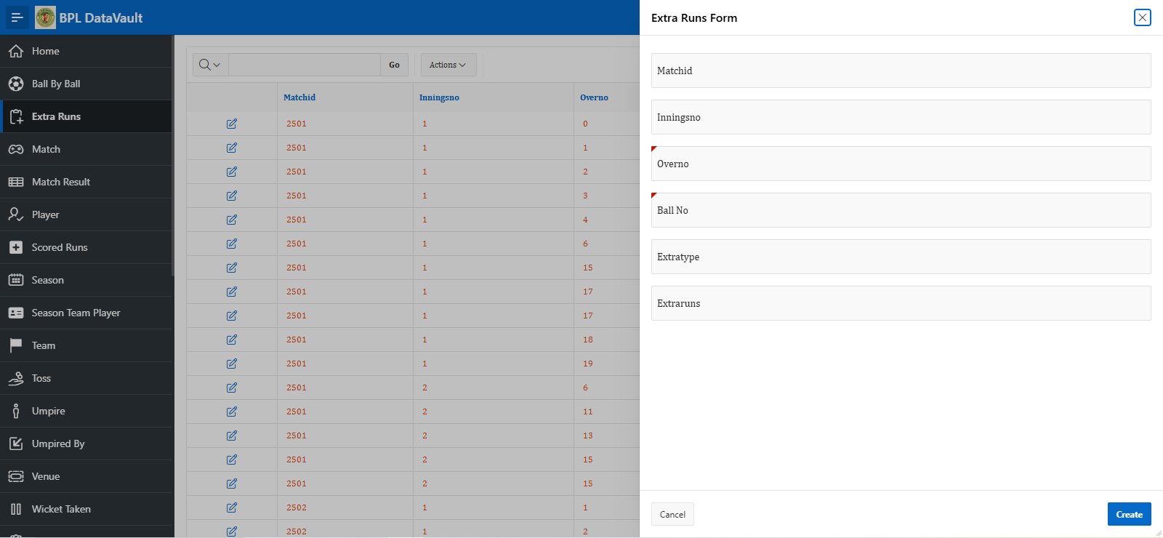

Page6: Match Report Page
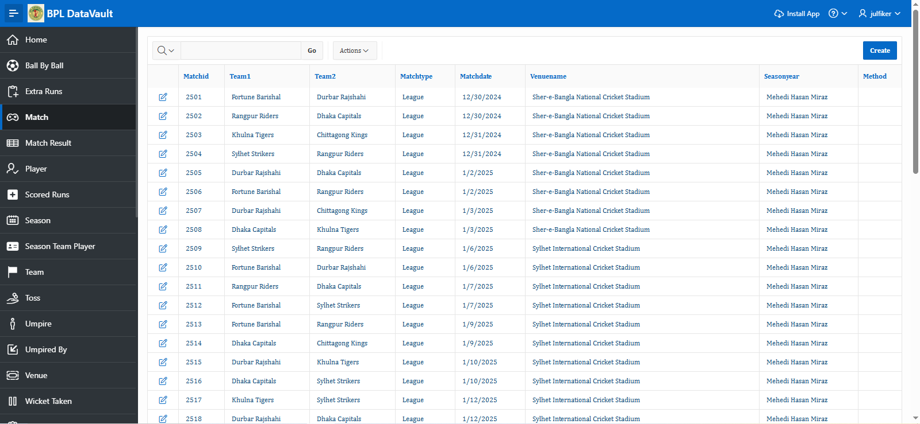

Page7: Match Form Page
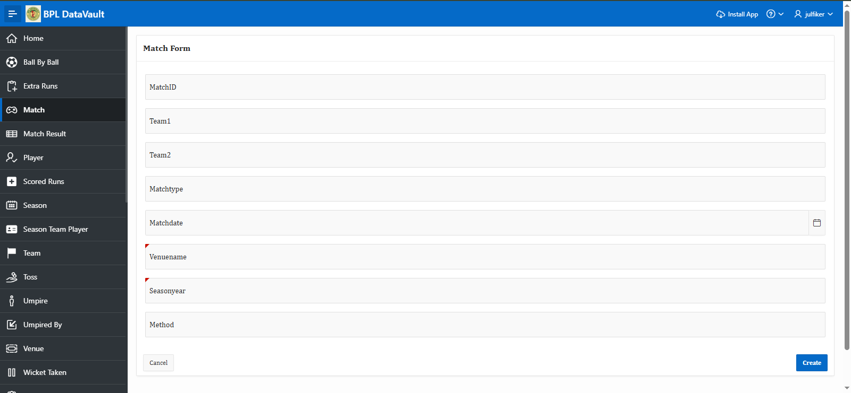

Page8: Match Result Report Page
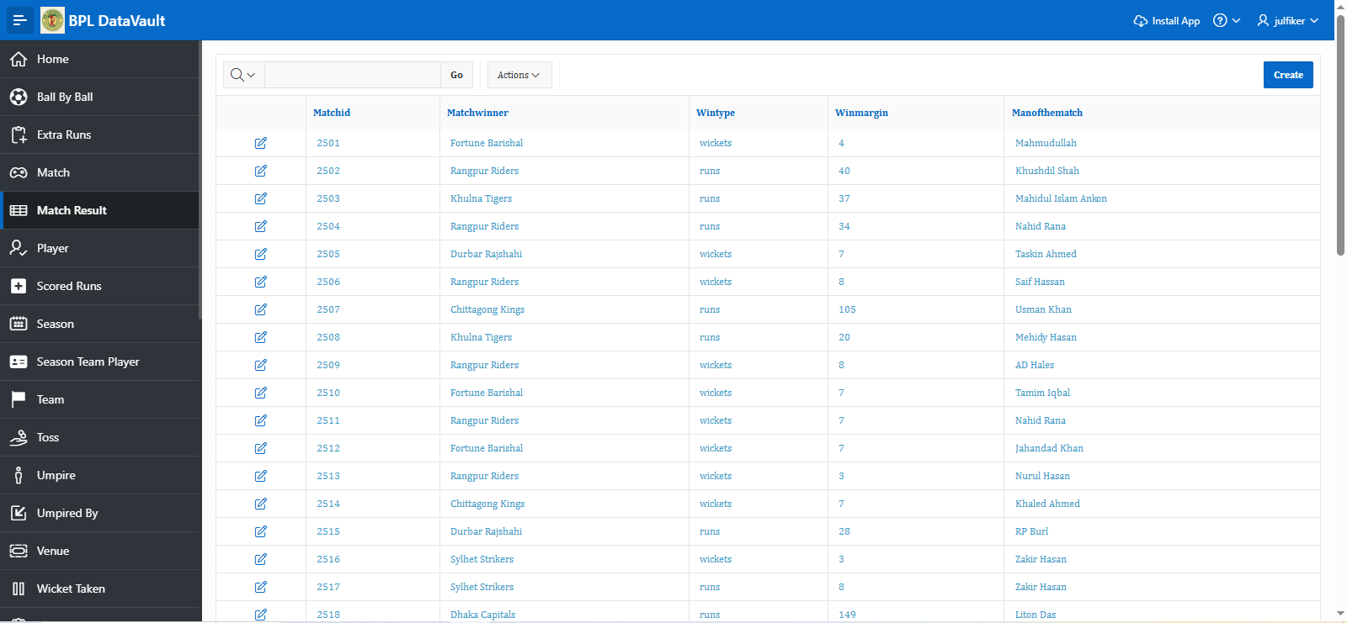

Page9: Match Result Form Page
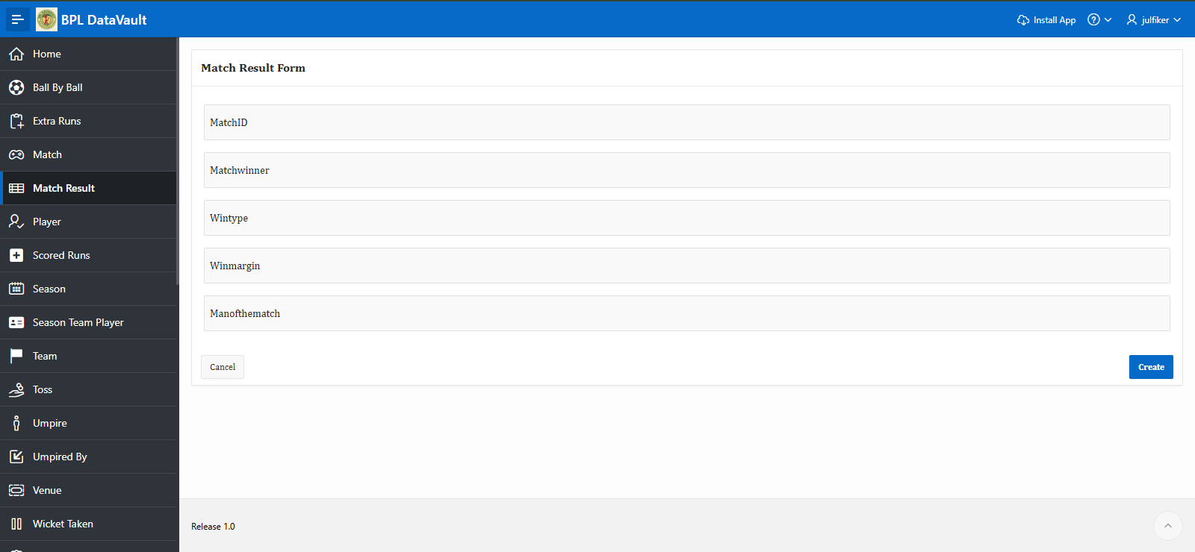

Page 10: Player Report Page
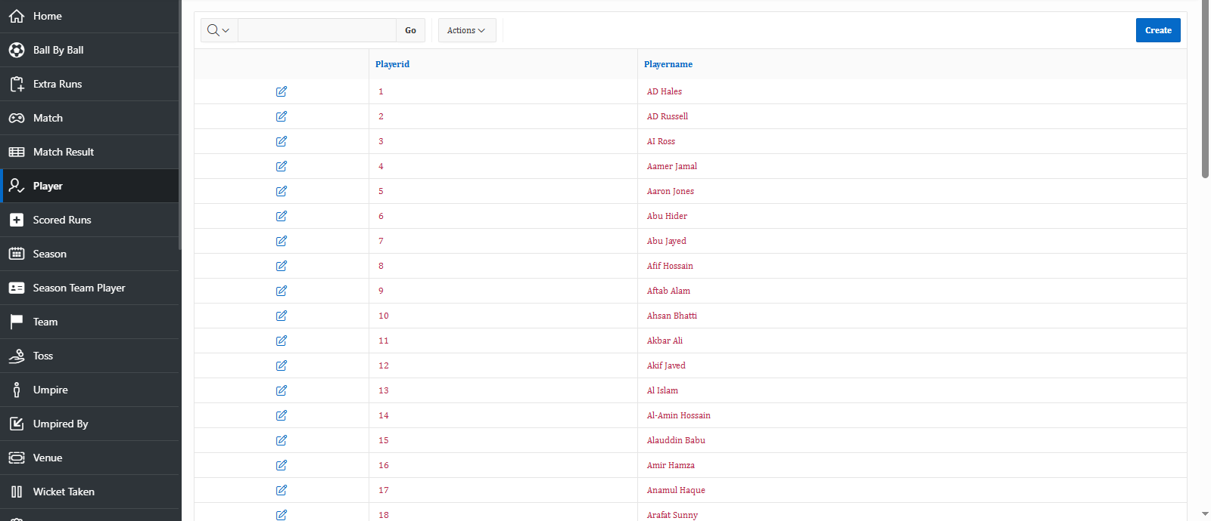

Page 10: Player Form Page
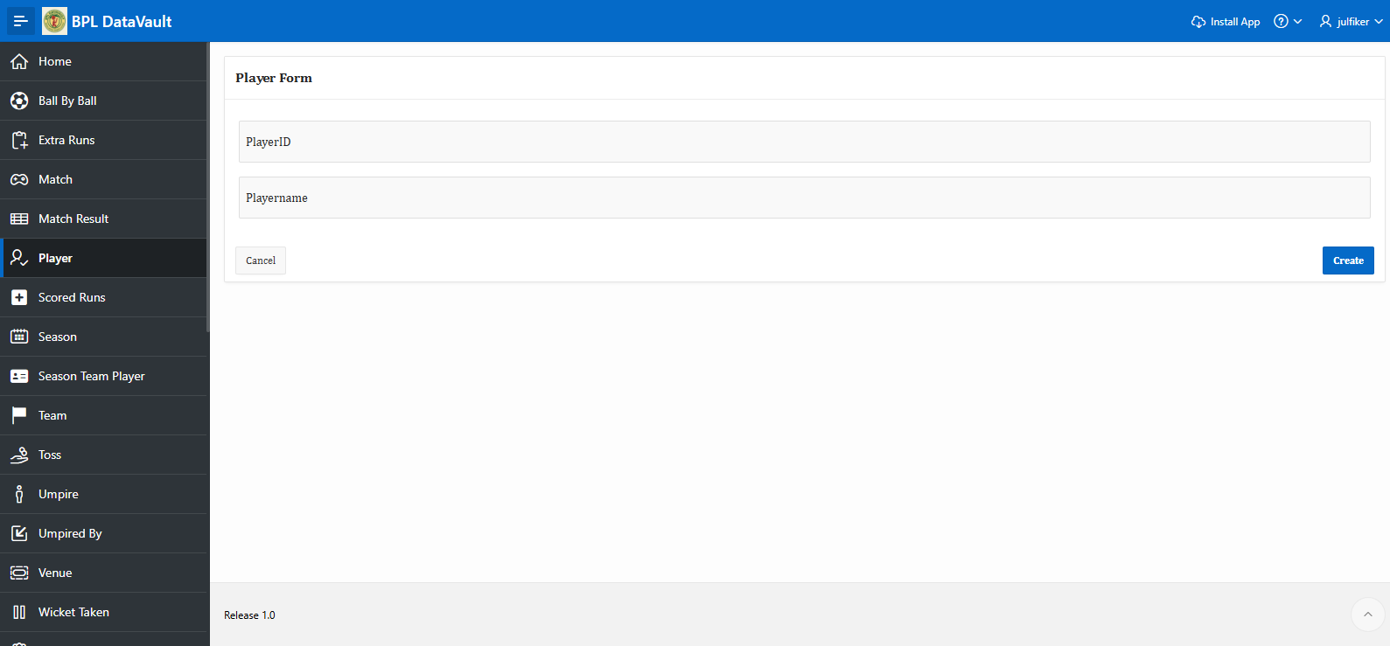

Page 12: Scored Runs Reports Page
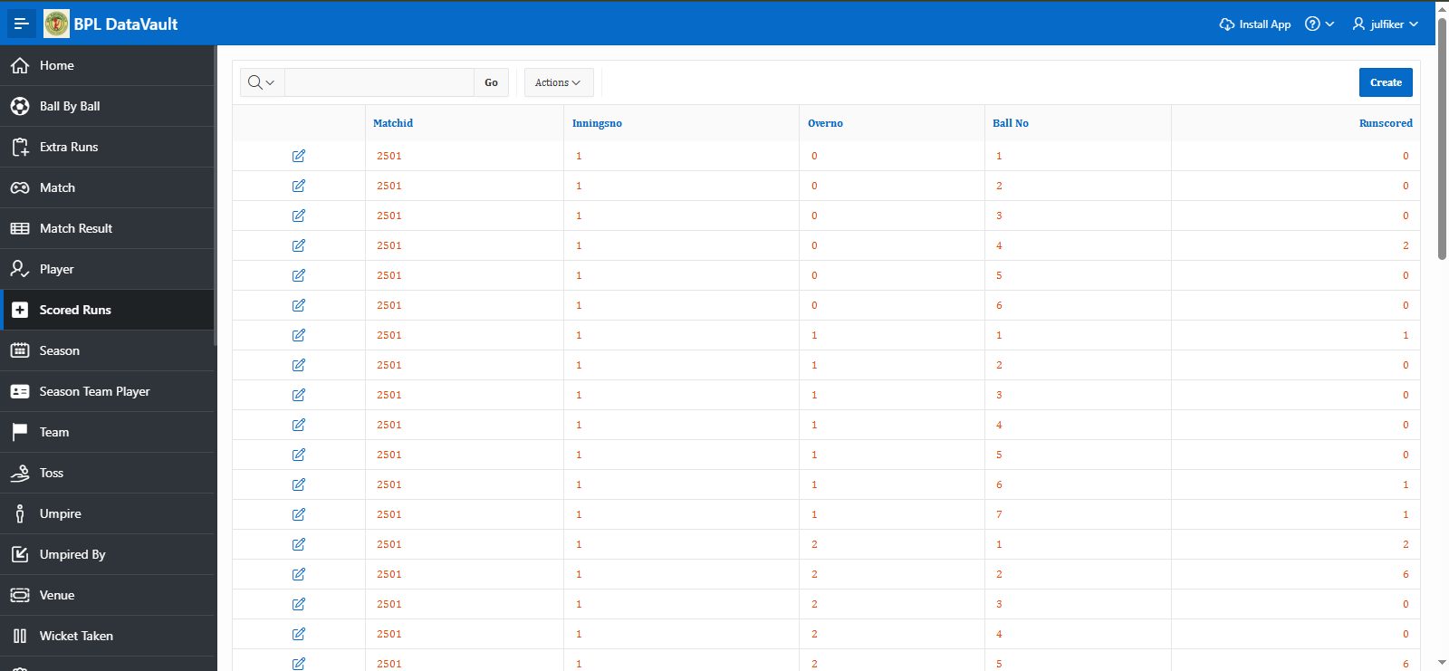

Page13: Scored Runs From Page
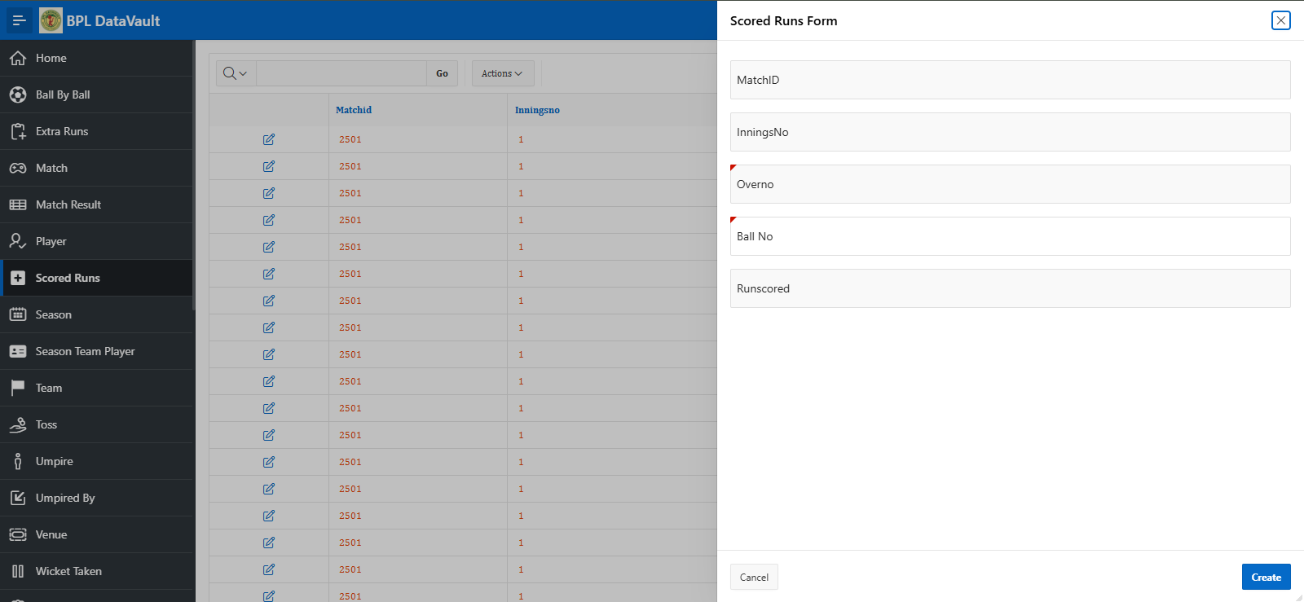

Page 14: Season Report Page
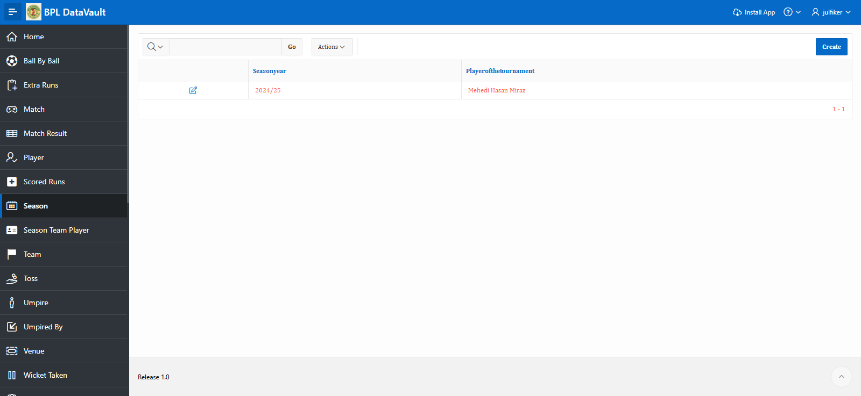

Page15: Season Form Page
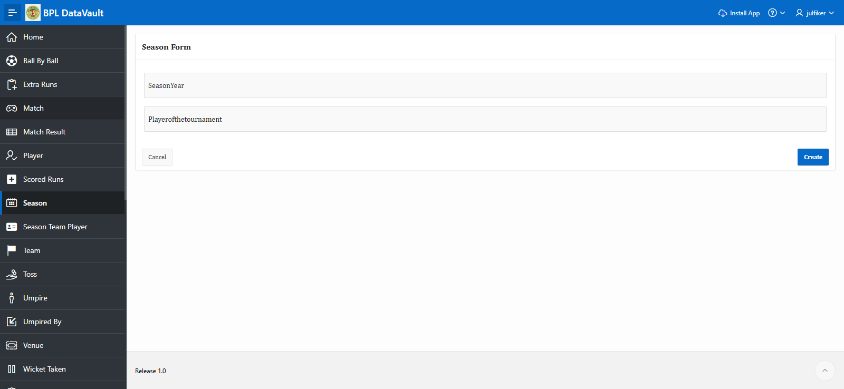

Page16: Season Team Player Report Page
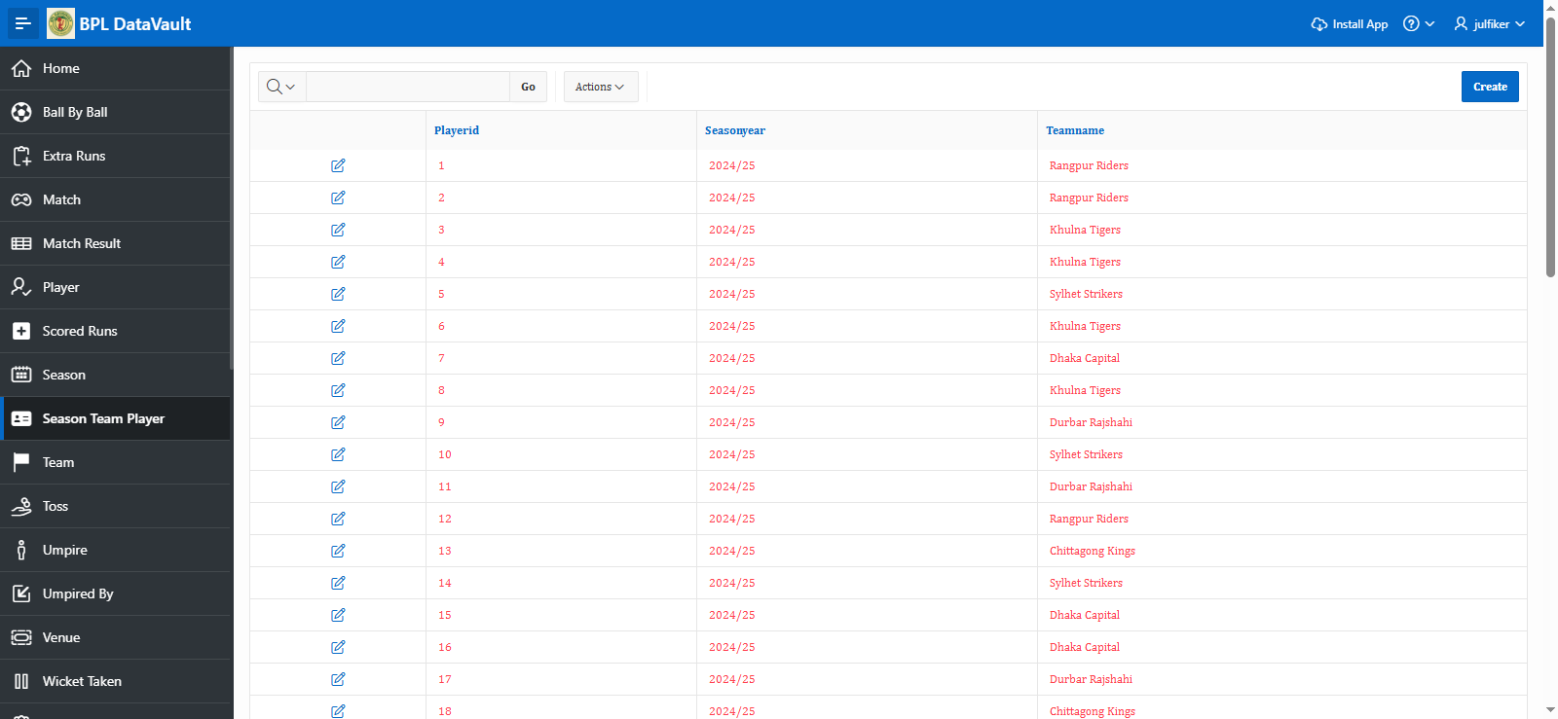

Page17:Season Team Player Form Page

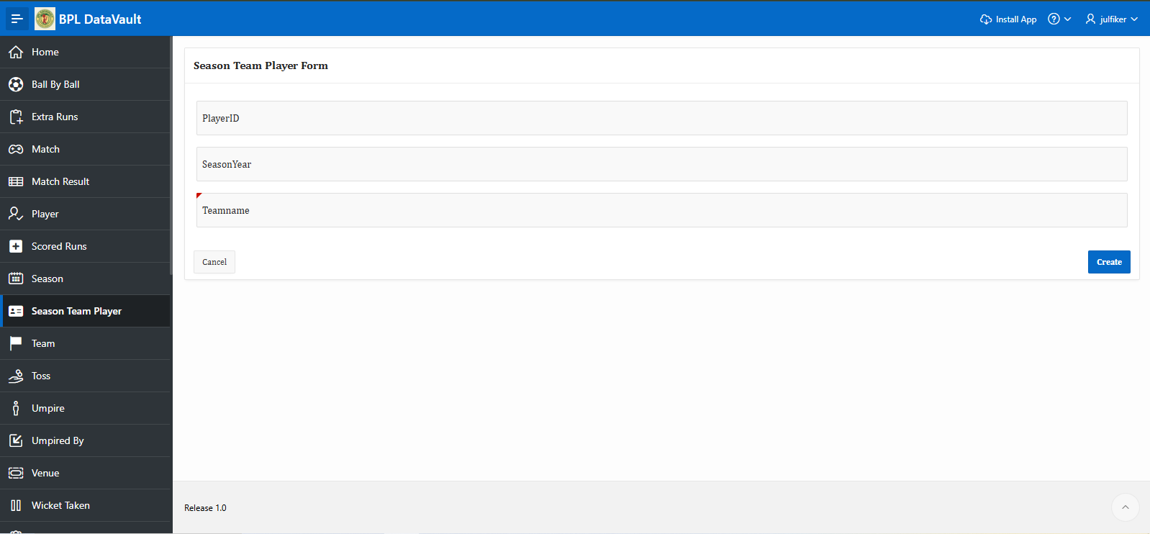

Page18: Team Report

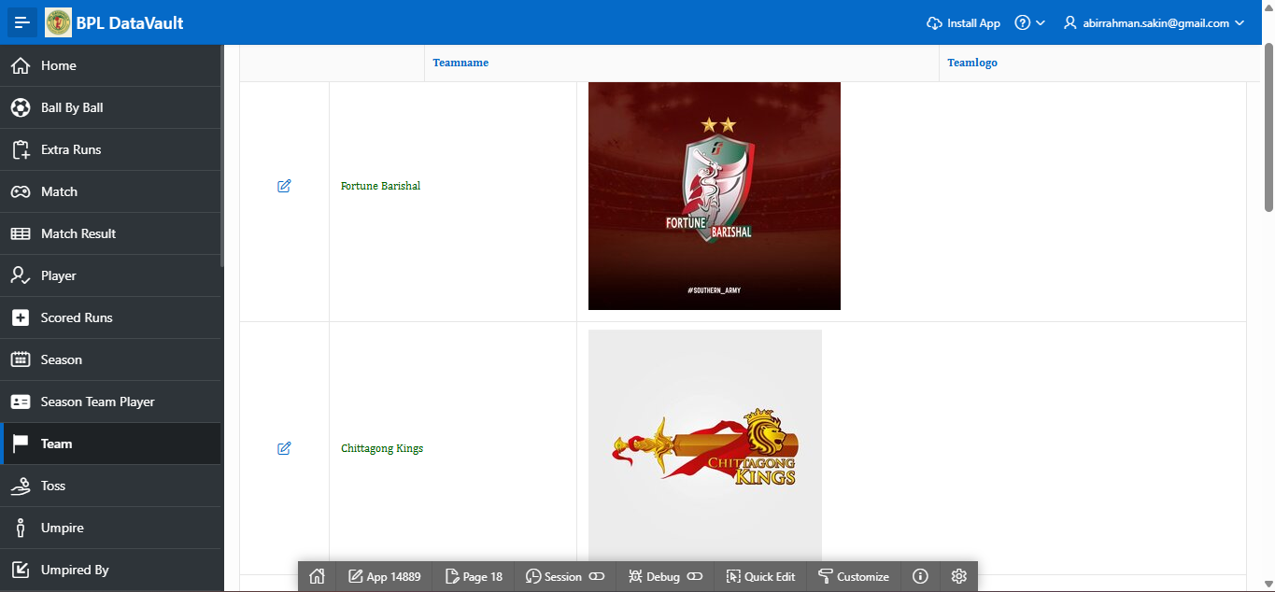

Page19: Team form page
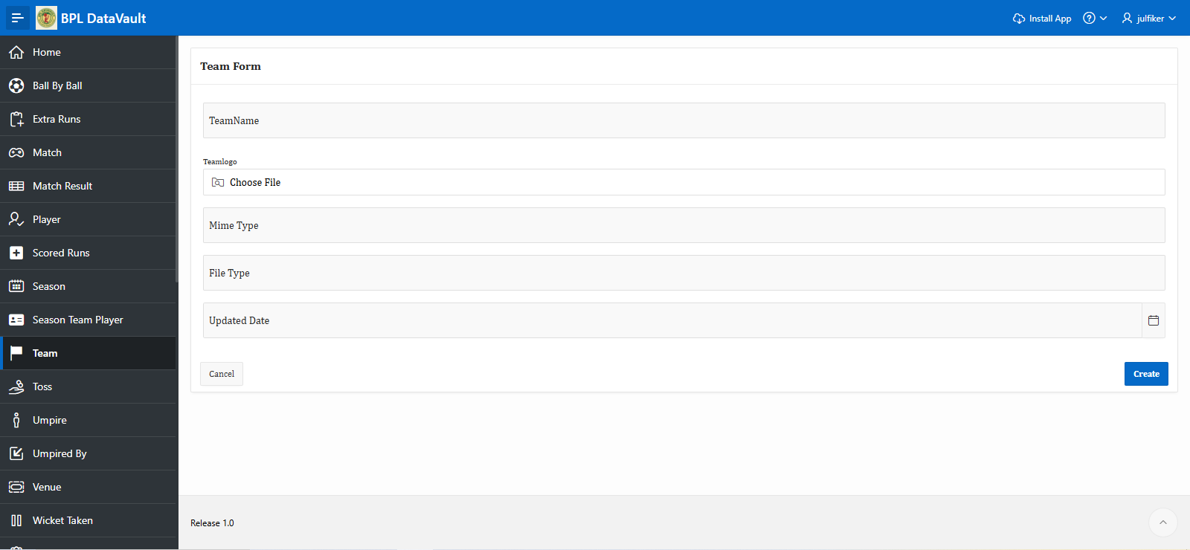

Page20: Toss Report

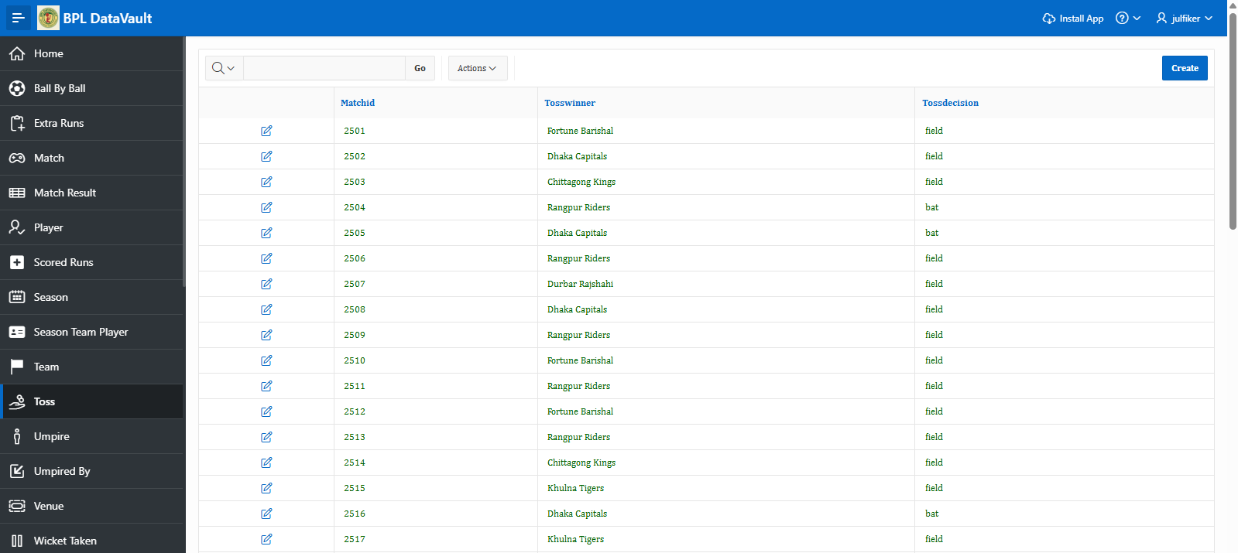

Page21: Toss Form Page
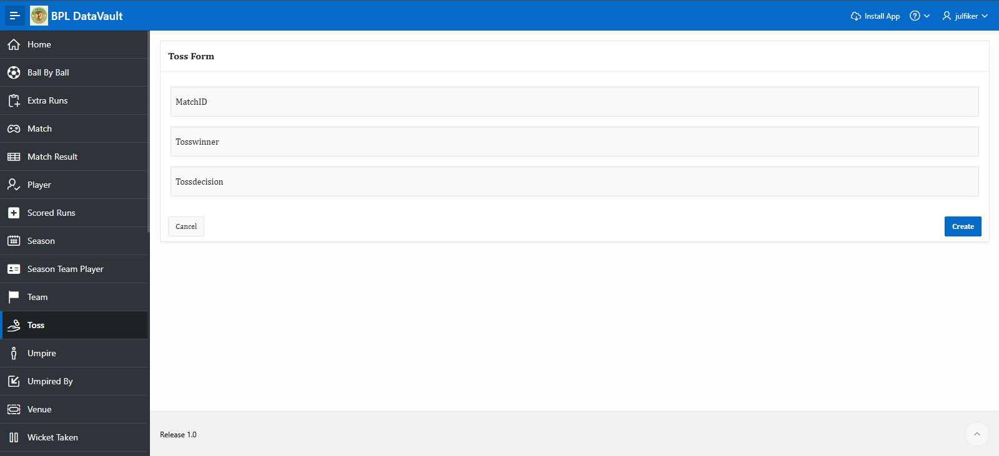

Page22: Umpire Report Page
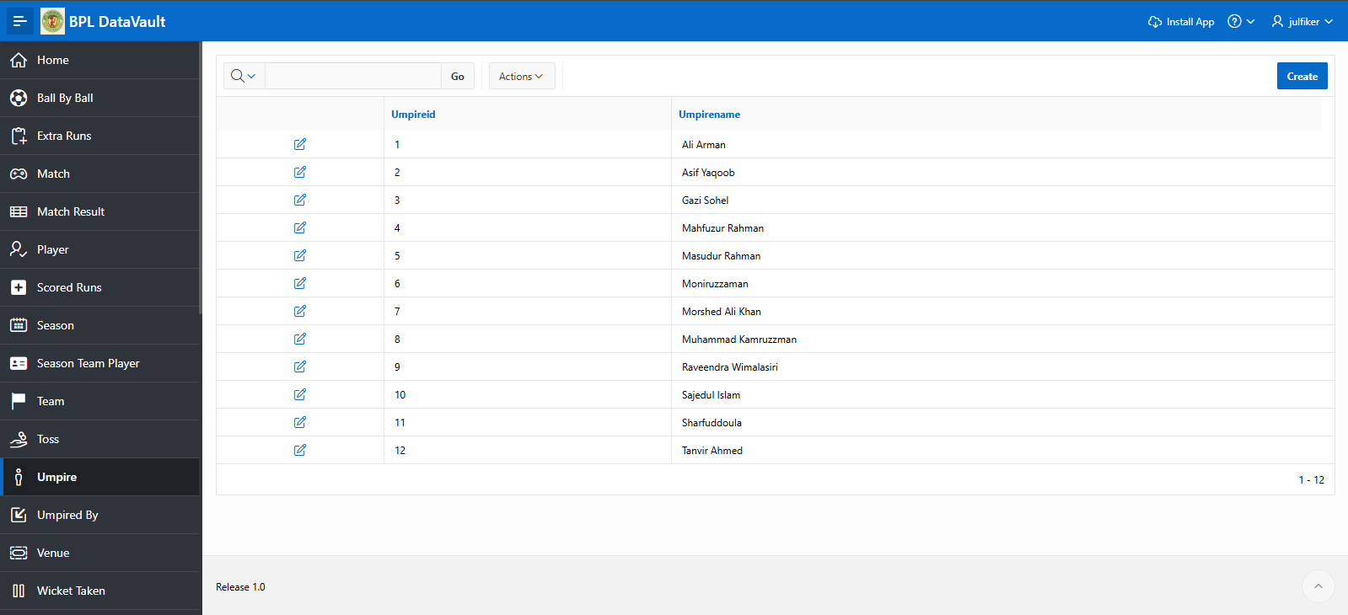

Page23: Umpire Form
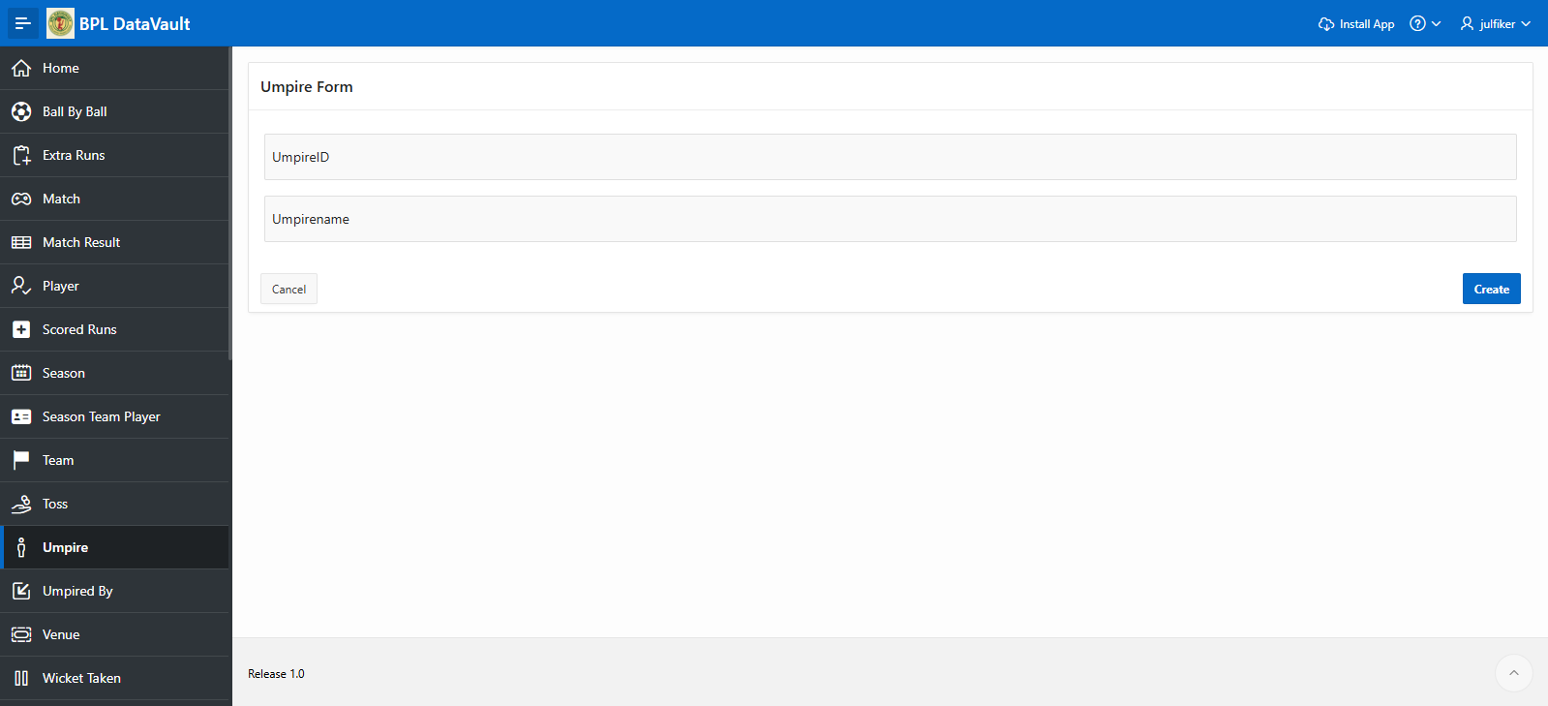

Page24: Umpired By Report page
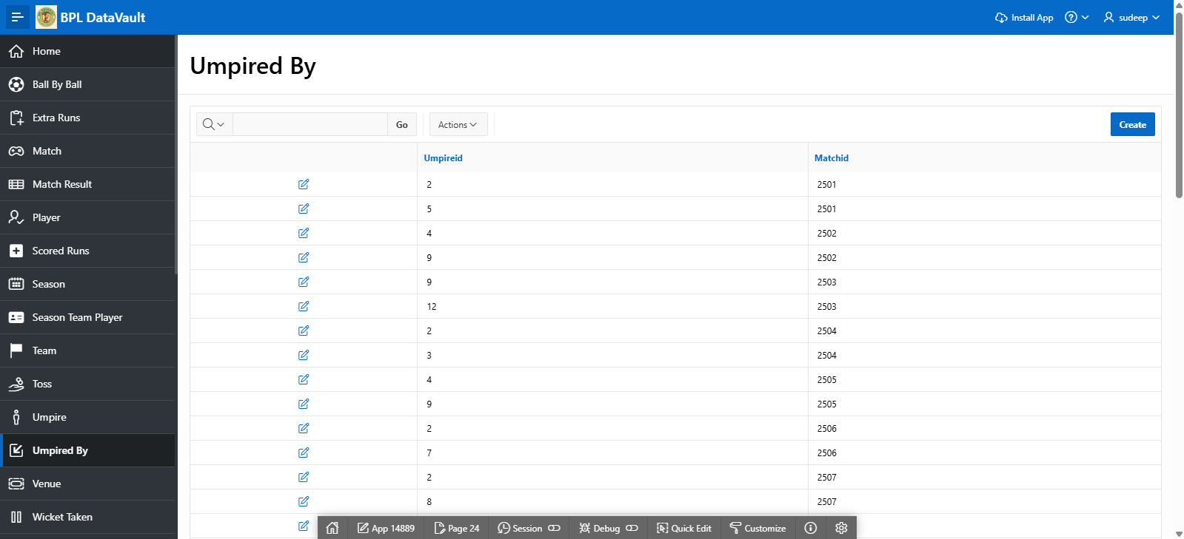

Page25:Upmired by Form Page


Page26: Venue Report Page
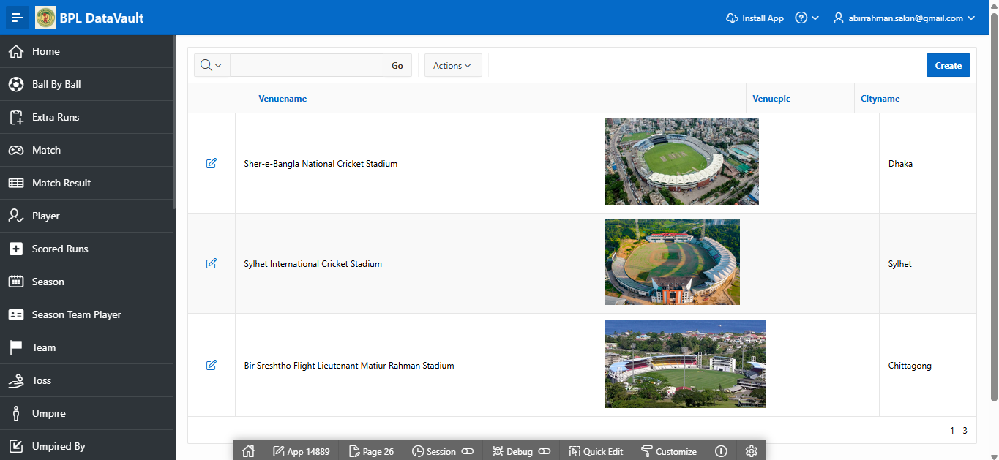

Page27:Venue Form Page
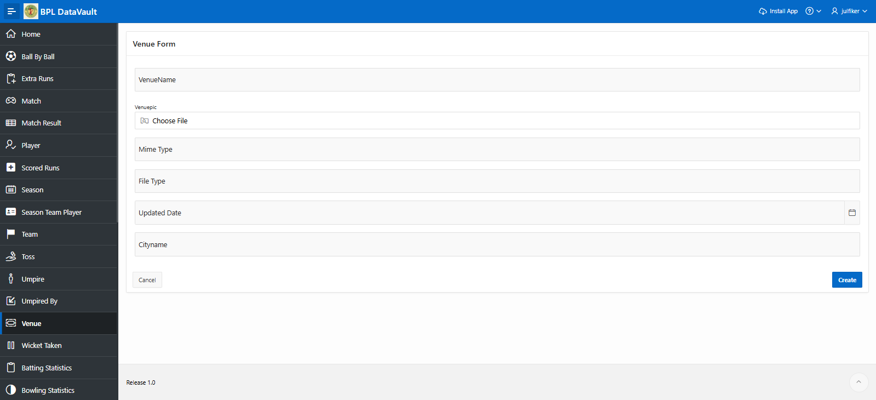

Page28: Wicket Taken Report Page
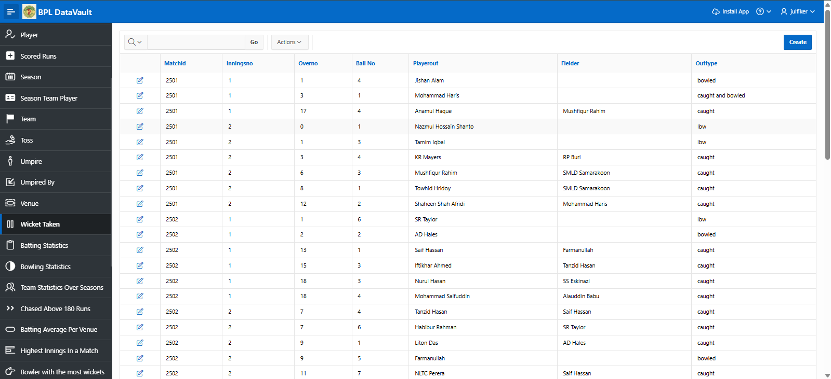

Page29: Wicked taken Form Page
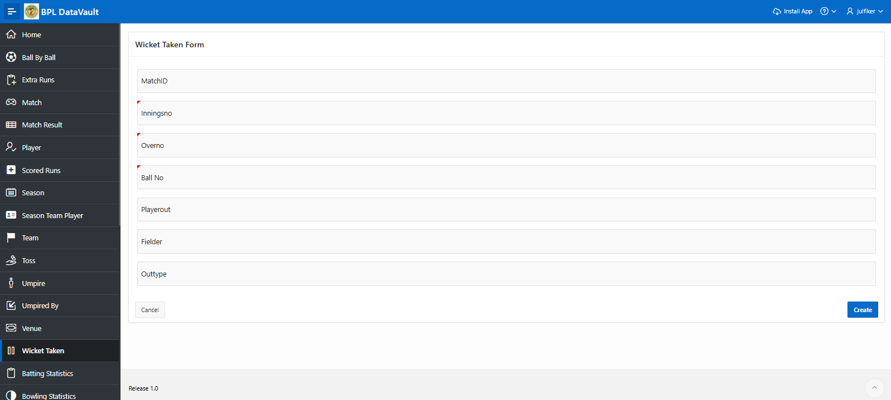

Page Number and Name | Query Type | Report description
30. Batting Statistics | Multi-table and  Aggregate | This page is based on  Query, Displays the  Batting statistics of all players , And a bar chart of top 10 run scorers.
31. Bowling Statistics | Multi-table and  Aggregate | This page is based on Query. Displays all bowlers ever bowled in IPL ,and their career Statistics . Added a bar chart to Show top ten bowlers.
32. Team Statistics Over  season | Multi-table and Aggregate | Team Statistics Over ALL Season
33. Chased Above 180  runs | Multi-table and  Aggregate | ALL matches chased over 180 runs scored in first innings
34. Batting average per venue | Multi-table and Aggregate | Batting average in each venue
35. Highest innings in a match | Multi-table and  Aggregate | Highest total in a match
36. Bowlers with most wickets | Multi-table and Aggregate | Bowlers who got most wickets in each season
37. Most sixes in each season | Multi-table and  Aggregate | Batters who hit most sixes in each season
38. Top win ratio | Multi-table and  Aggregate | Top5 Teams with most win ratio across season
39. Toss Impact in a match | Multi-table and  Aggregate | Toss Impact in a match across all seasons. Toss' decision led to winning records.
40. Most MOTM | Aggregate | Most MOTM in each season
41. Match Wasted in D/L method | Aggregate | Match Wasted in D/L method in each season

Page30: This page is based on Query, Displays the Batting statistics of all players , And a bar chart of top 10 run scorers.
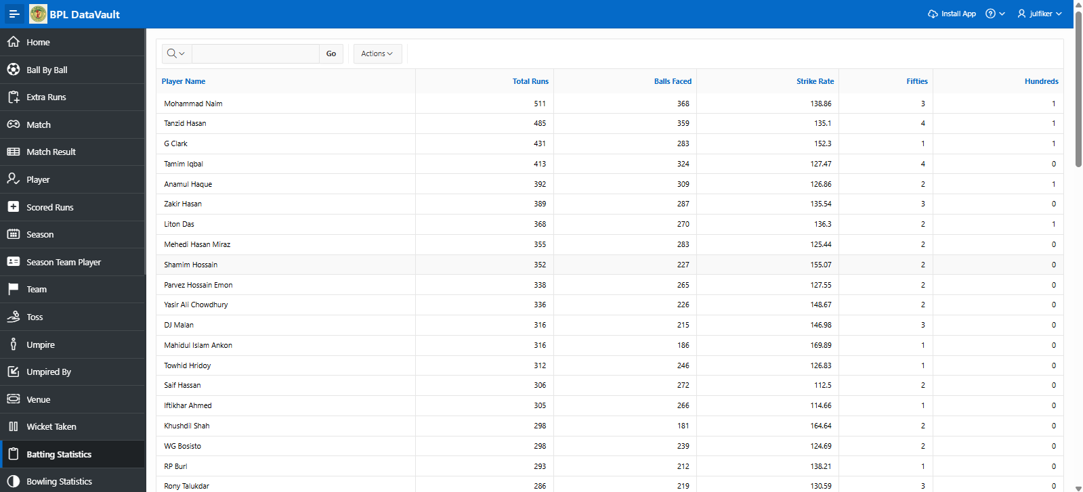

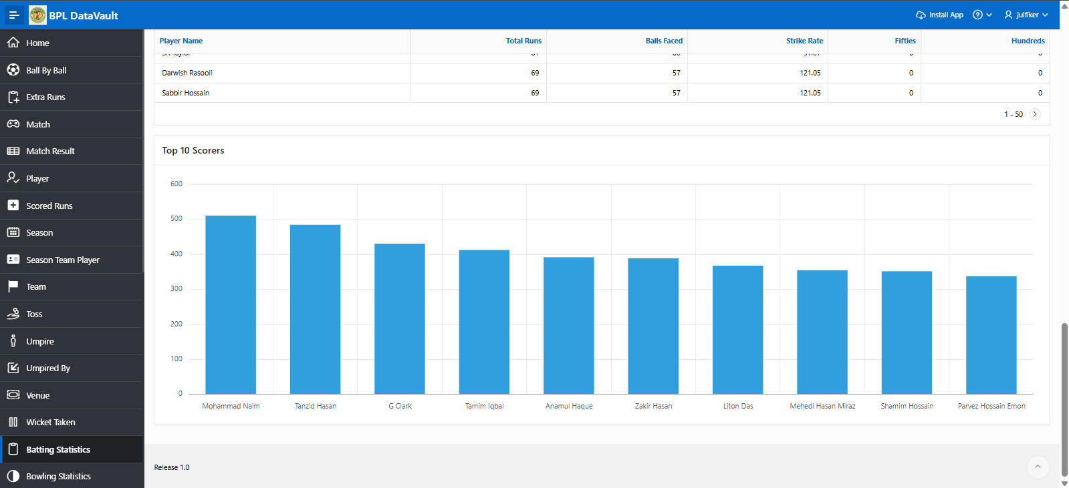

Page31:This page is based on Query. Displays all bowler ever bowled in BPL and their career Statistics . Added a bar chart to Show top ten bowlers.
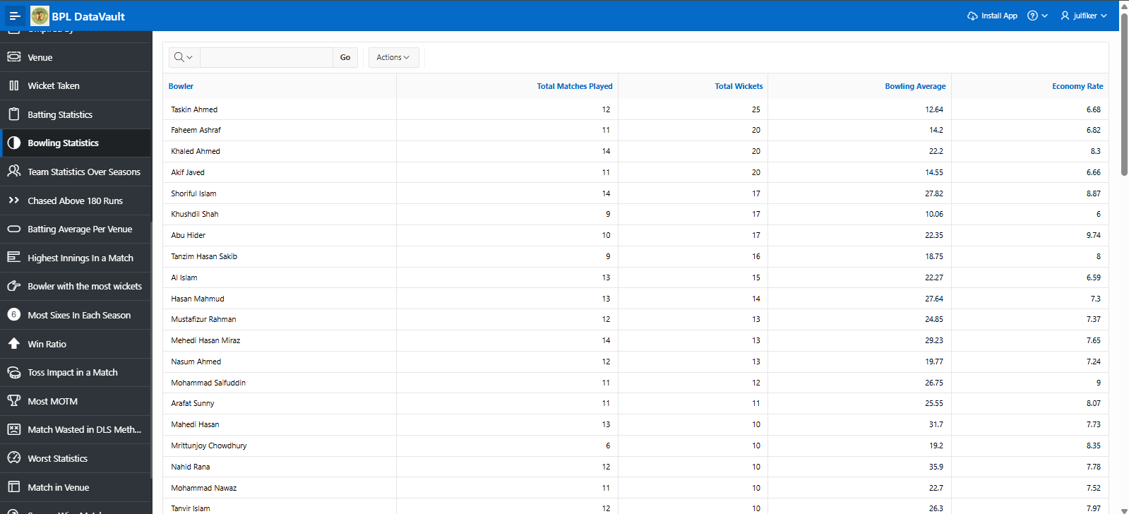

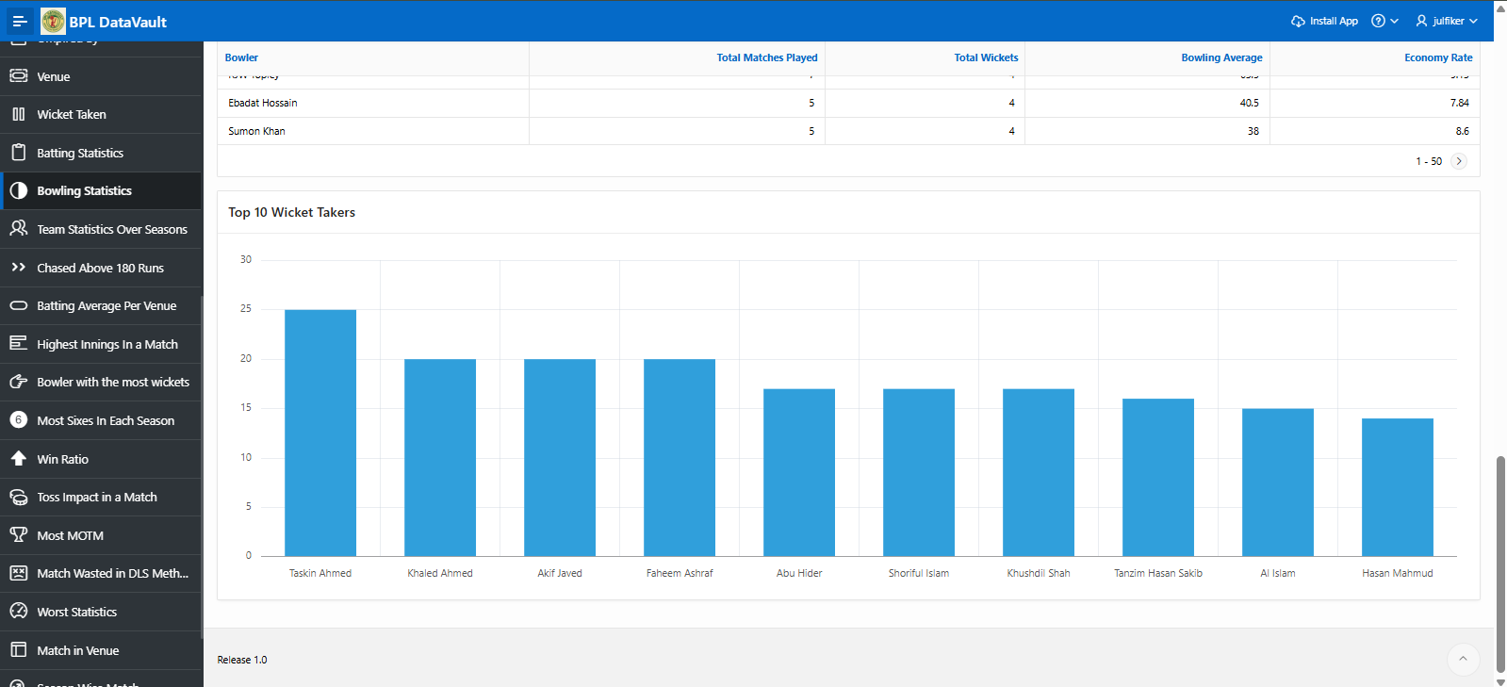

page32: Team Statistics Over ALL Season
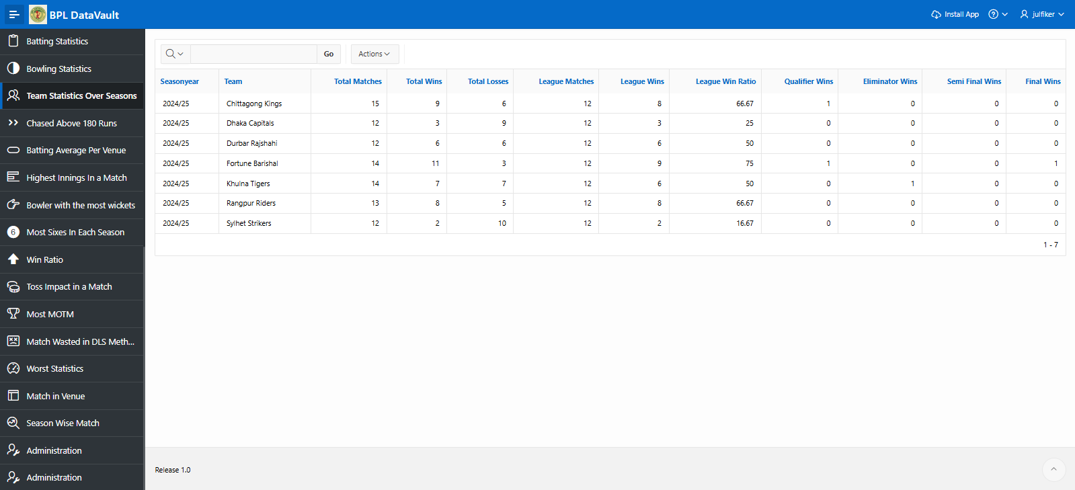

Page33: ALL matches chased over 180 runs scored in first innings
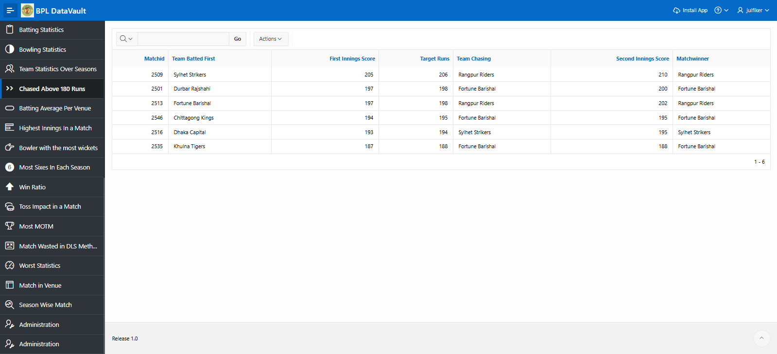

Page34: Batting average in each venue
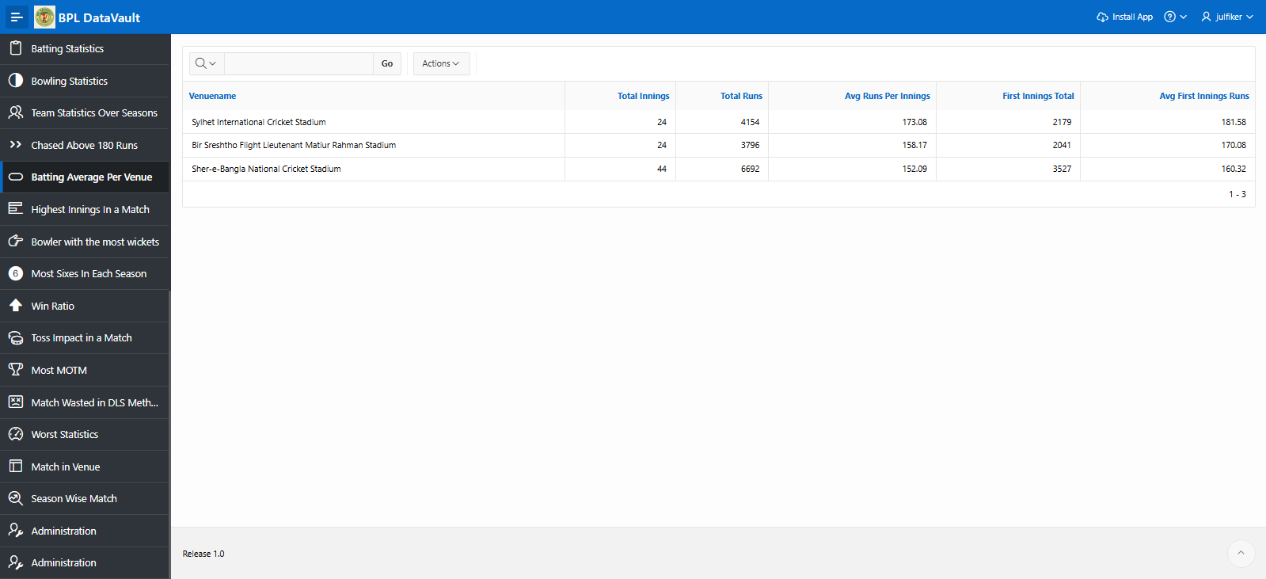

Page35: Top 5 Highest innings in a match
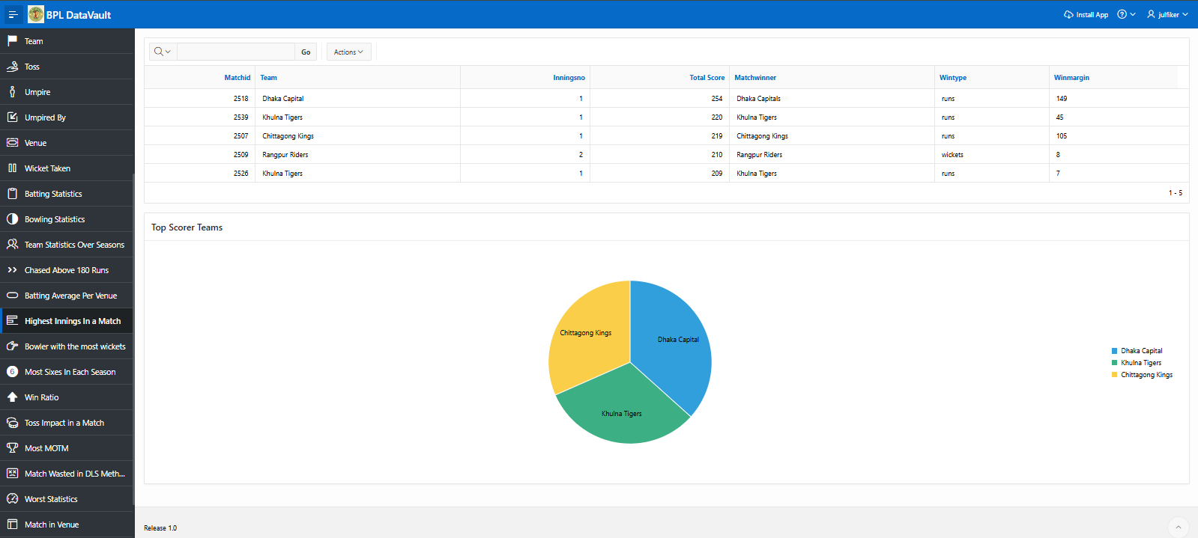

Page36: Bowler with most wickets
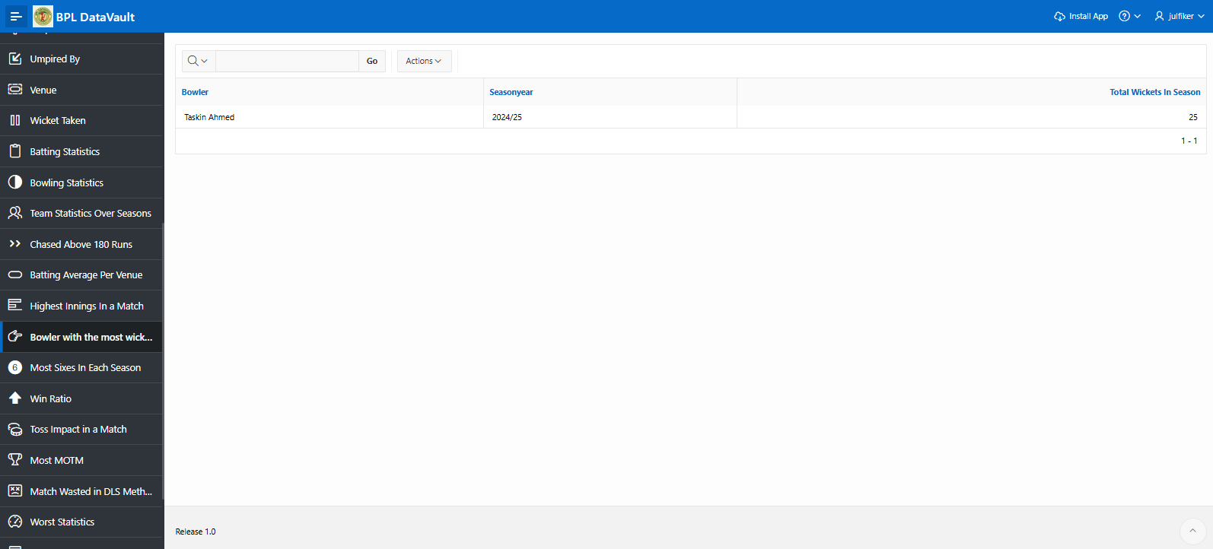

Page37: Most sixes hit by a player in each season
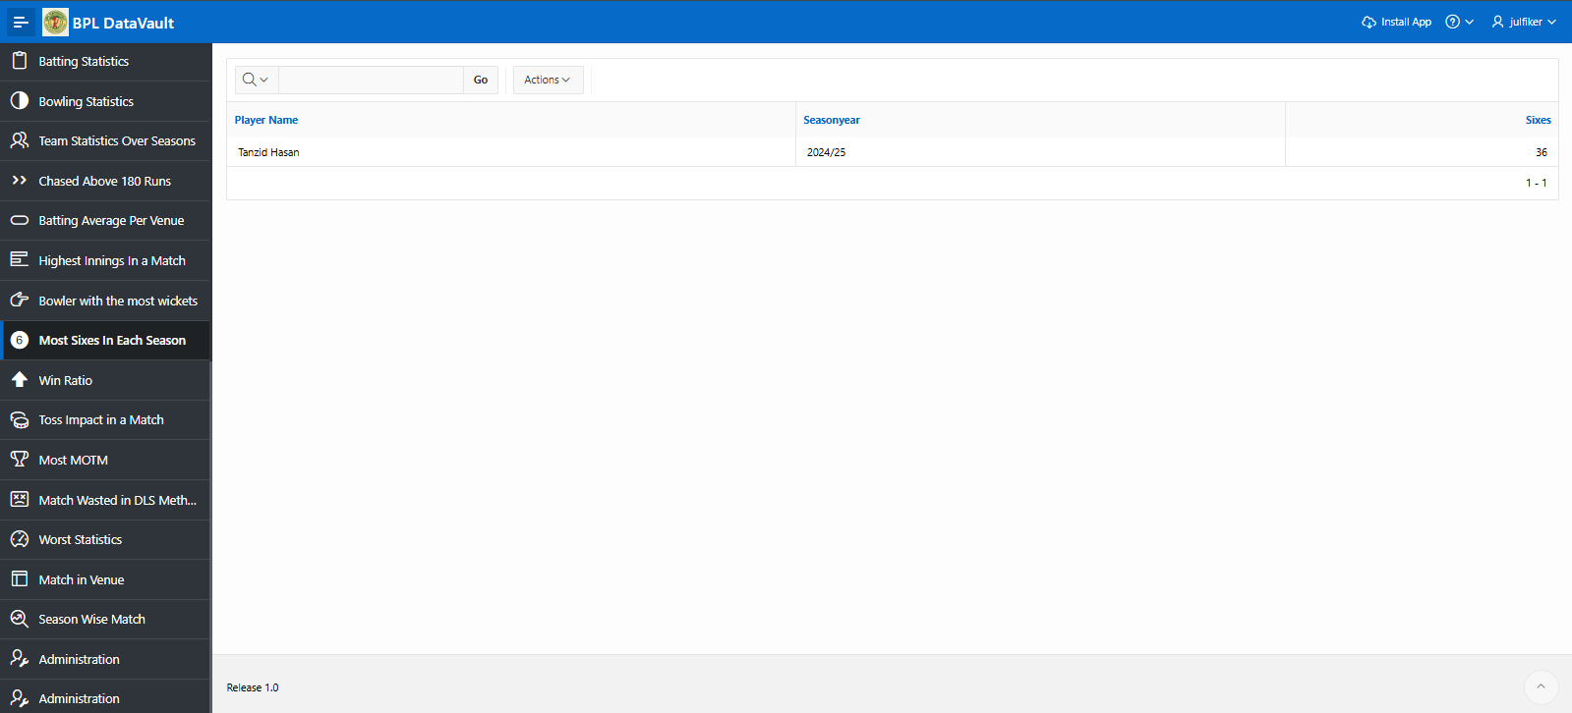

Page 38: Win ratio of all team
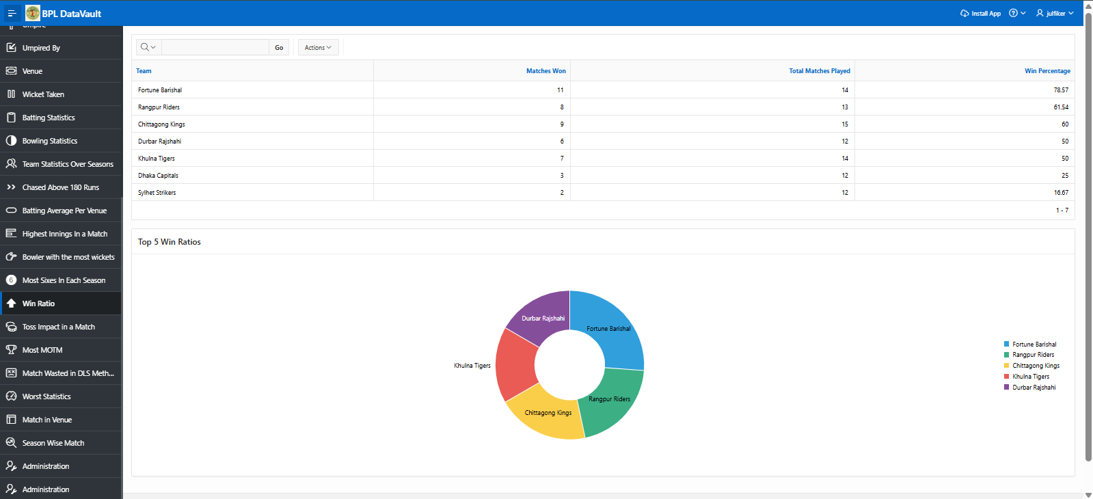

Page39: Toss Impact in a match
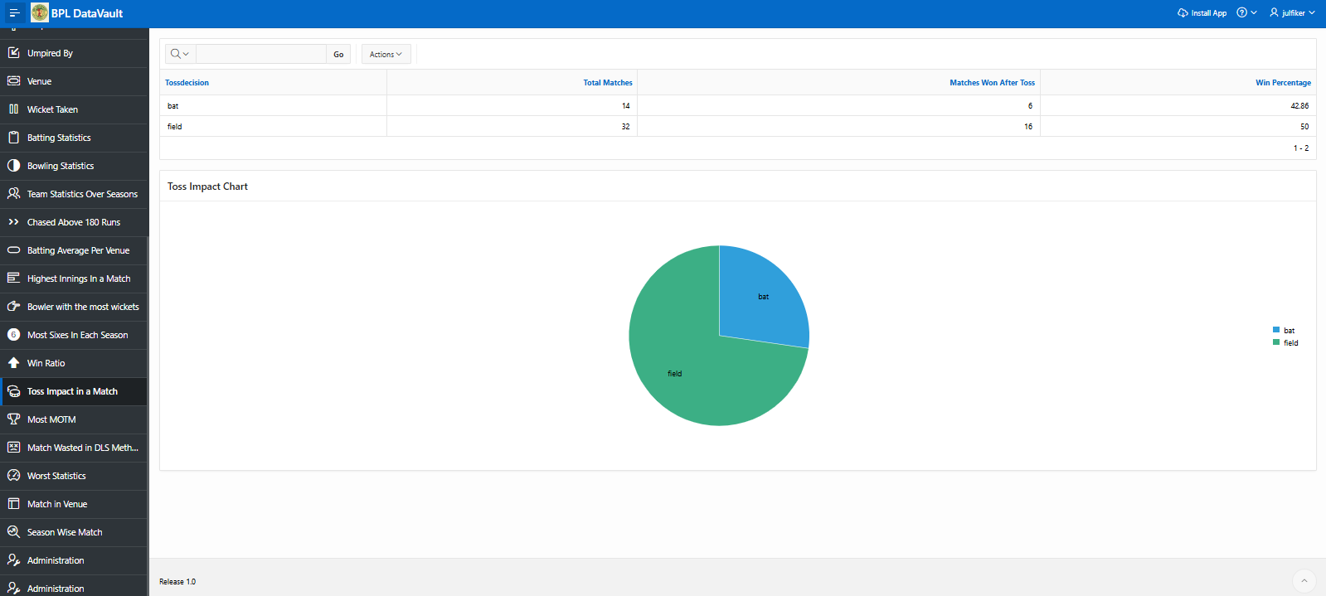

Page40: Most Man of the match award
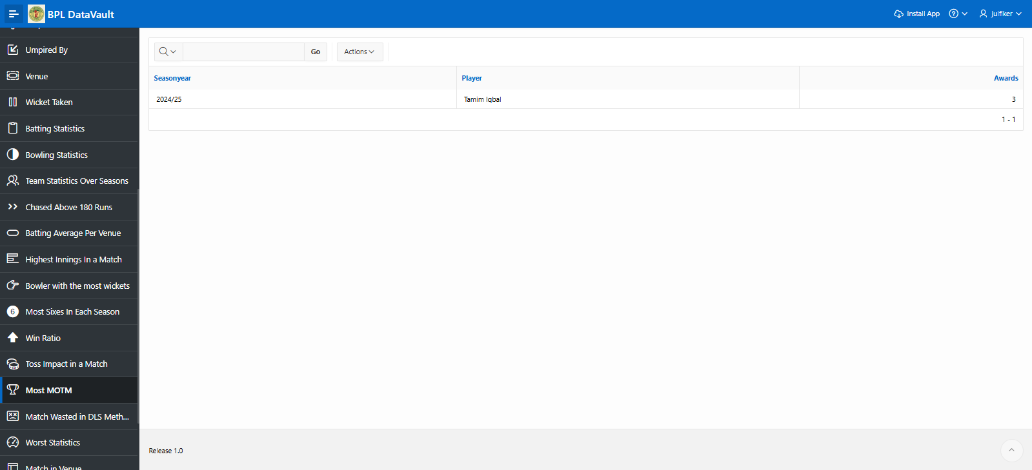

Page41: Matches which end up in D/L method
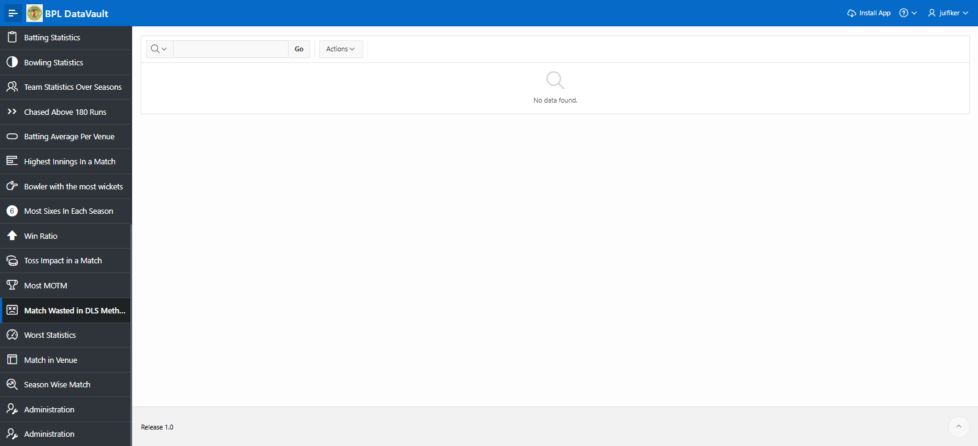

Page number & Charts | Chart description
42. Worst Statistics | Worst Records:  Top10 Batters with most DUCKs  Top 5 Safe hands  Top 5 Bowlers with extra runs  Top5 Bowlers with worst economy

Page42: Worst Records
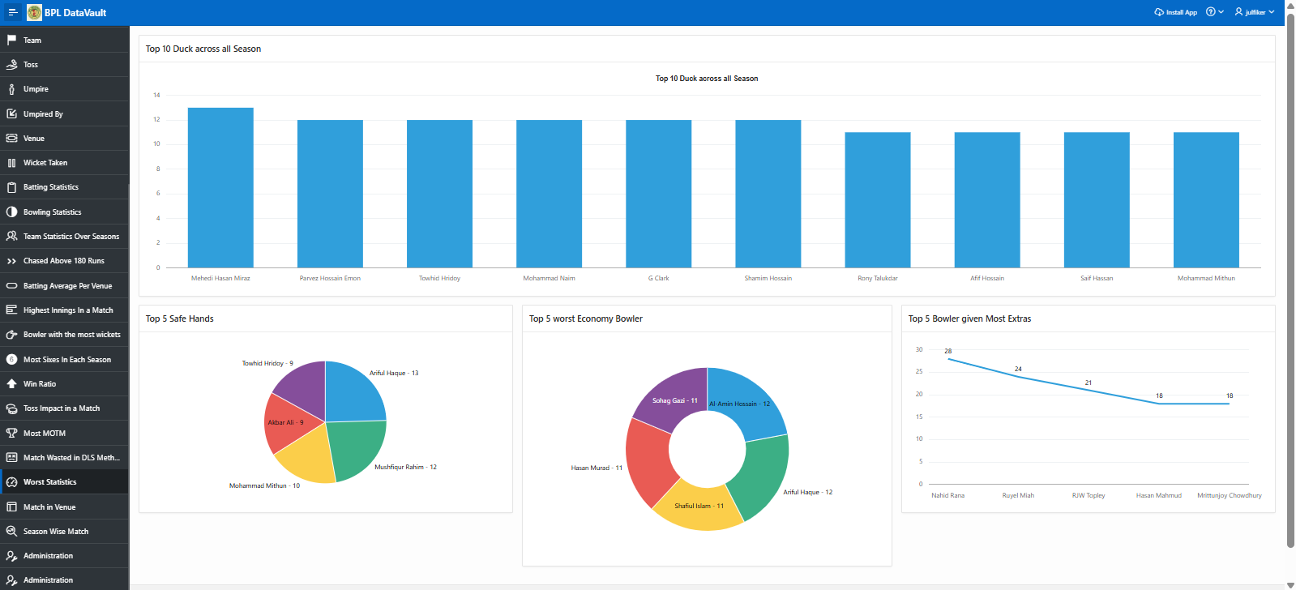

Page & Name | Master(Parent) | Details(Child)
43. Season wise Match | Season | Match
44. Match in Venue | Venue | Match

Page43: Season wise match details

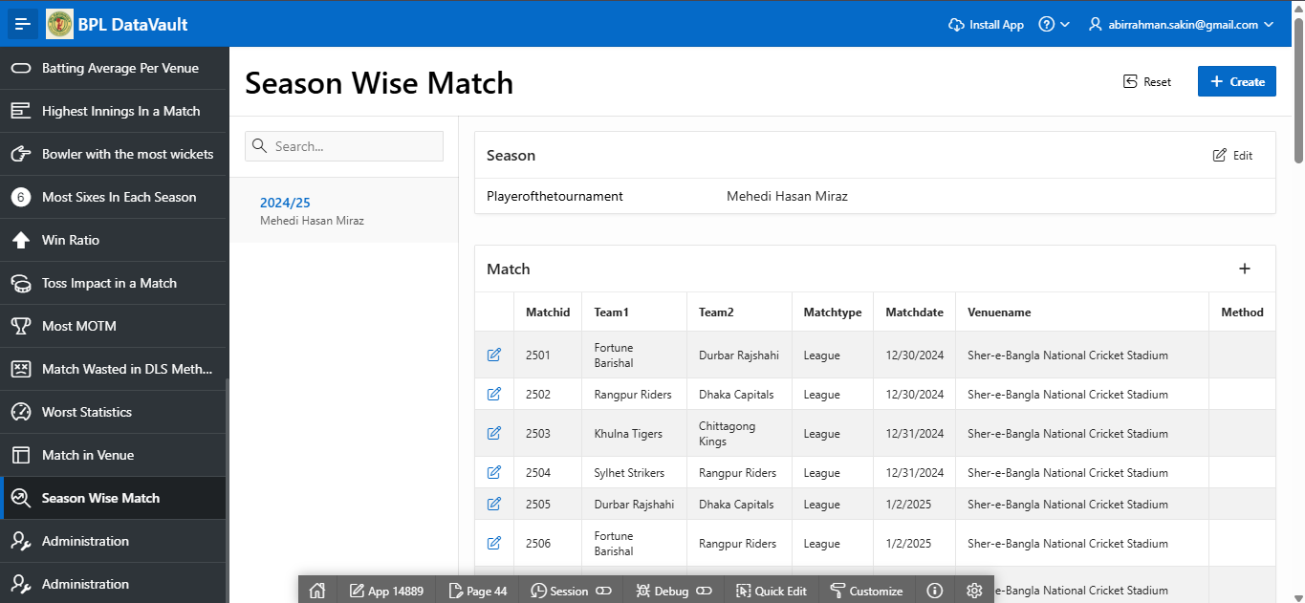

Page 44: Match Statistics in all venues.
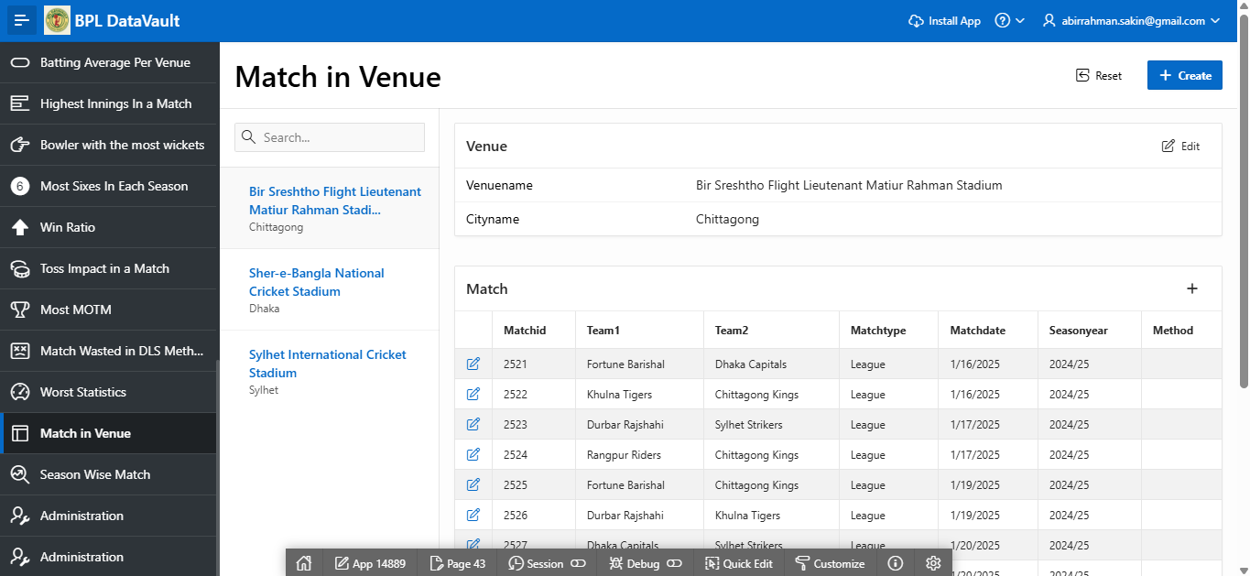

Authorization and User Role Assignment:

UserName | Password | Role
abirrahman.sakin@gmail.com | #spsakin@329 | Administrator
sudeep | sheep | Administrator
julfiker | monkey | Administrator
sakin | lion | Administrator
rashed | rashed | Administrator
thor | loki | Contributor
messi | goat | Reader
neymar | goat | Reader
ronaldo | goat | Reader

Page-wise Authorization Information
Page number and name | Authorization Level
10000 | Administrator
All the pages (expect Create , Delete, Update & Save button) | Reader

Page:1000 [Administration Page]
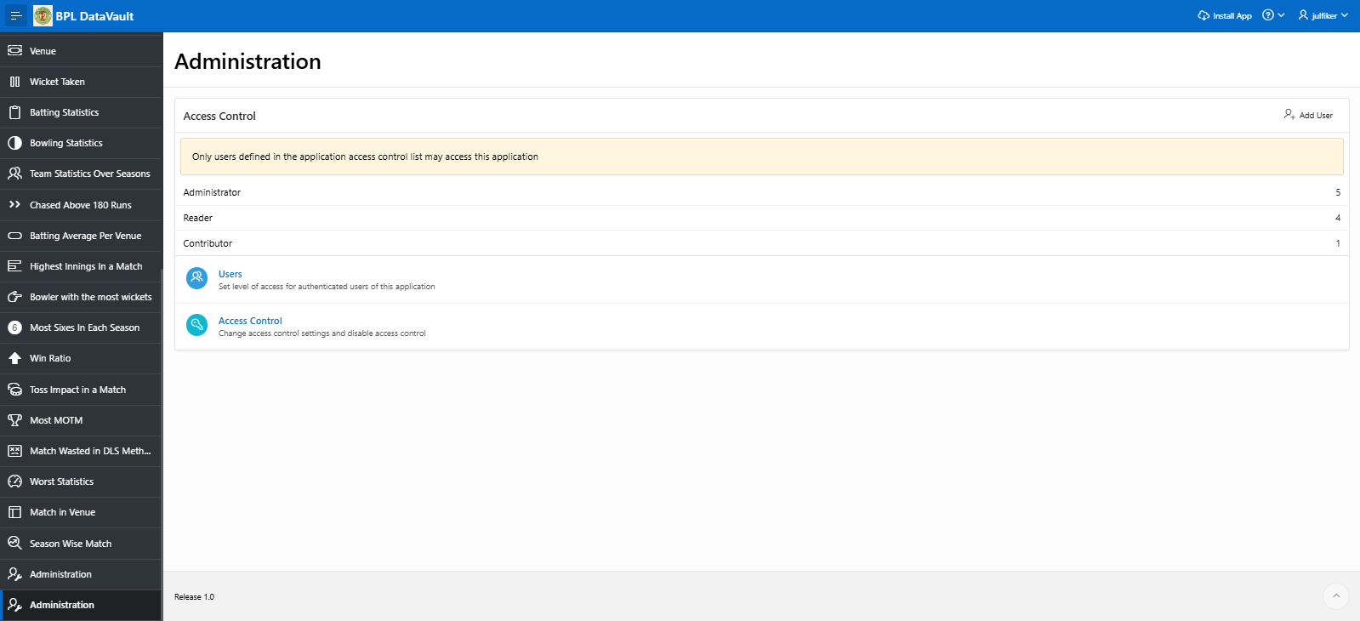

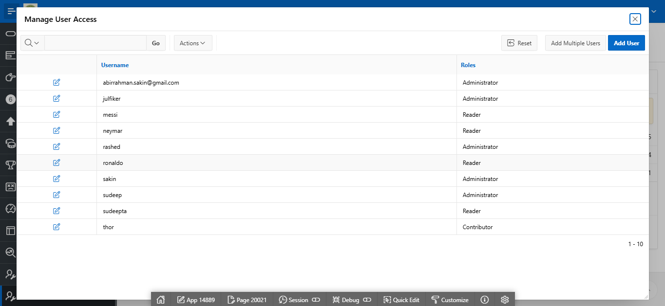

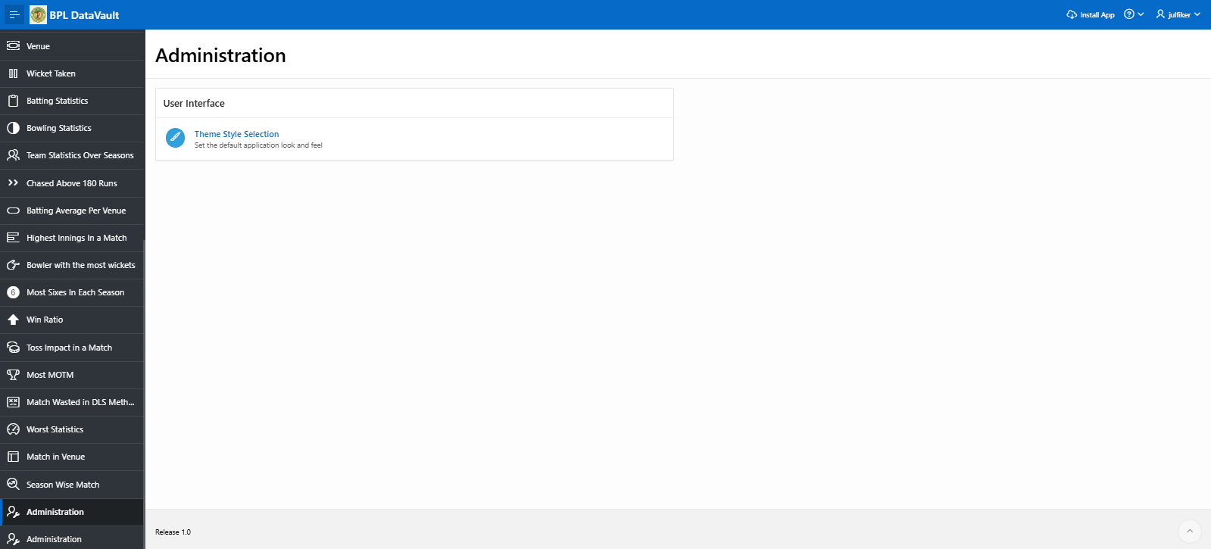

Conclusion:
This project was both a challenging and rewarding experience that pushed us to grow both technically and intellectually. It deepened our understanding of database management principles, from designing efficient schemas to writing complex queries and ensuring data integrity. Along the way, we encountered several obstacles that required critical thinking and creative problem-solving, which ultimately strengthened our analytical abilities. Beyond the technical aspects, this journey taught us the importance of patience, persistence, and continuous learning—skills that we will carry forward into future projects and professional endeavors.

The end

